Metrics optimization

If your model is scored with some metrix you get best results by optimizing exactly that metric in most of the cases.

You should also do Exploratory data analysis as well as exploratory metric analysis in some cases to find other ways to optimize it.

Evaluation metrics:

Regression:

* MSE, RMSE, R squared
* MAE
* (R) MSPE
* (R) MSLE

CLASSIFICATION:

* Accuracy
* Logloss
* AUC
* Cohens kappa

**MSE mean squared error**

Lets say we want to find a constant value given as our prediction, for which when found out the mean square value using the actual prediction. We will get the least mean square error or it can be said as the baseline prediction value.

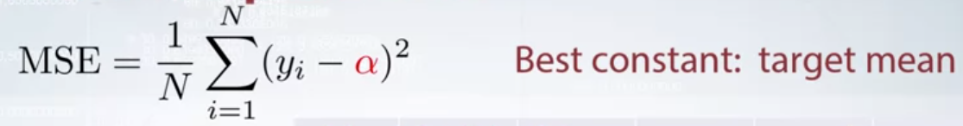

**RMSE root mean squared error**

RMSE and MSE are the same in many ways and so dealing these problems with MSE can also work.

They just differ

Minimizer of MSE is also the minimizer of RMSE. Because square root function is non decreasing.

It’s a lil bit different for gradient based models.

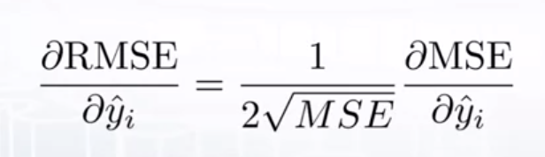

The difference between both is just the gradient calculation in the ith value prediction.

As you can see it is just a constant multiplied in MSE. We can say that the gradient travelling is

The same in both the cases just with a different learning rate. So they cannot be directly INTERCHANGEABLE for gradient based methods and we’ll need to adjust certain things like the learning rate.

As a constant value of both MSE AND RMSE cannot tell us if the value is good or bad. Like 32 as MSE value cannot be said as good or bad without knowing the target values and the distribution of them. Therefore we have another metric called the R2 or Rsquared error.

**R2 or R squared error:**

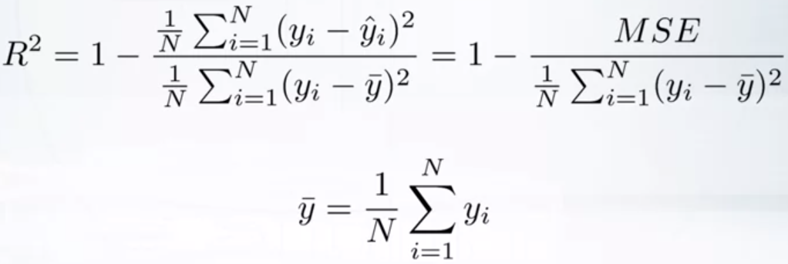

As we can see an MSE value equal to our baseline value (it is a value for a constant prediction = mean value which as we have seen is the best for a baseline prediction)

So having a MSE of zero is going to give an R2 of 1 which is the best and having an MSE equal to the mean prediction baseline will lead to an R2 of 0. Therefore R2 magnitude value alone can tell us how

Good the model is performing.

Also we can use MSE also in place of R2 squared as it is just MSE divided by a constant value (baseline score) and subtracted by another constant (1) value.

**Mean Absolute Error:**

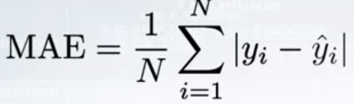

As you can see it doesn’t penalizes errors not as badly as MSE and RMSE does.

Also It is mainly used in finance where the exact error is counted. Like a 10 dollar error

Is a 10 dollar one and giving to MSE with create it as an error value of 100.

So MAE is also easy to justify to your boss of higher authorities when asked.

The constant which can create the least MAE is **median.** As a value in the middle of the

Values in ascending order makes sure that the absolute difference values are as smaller

As possible.

Also as nothing is squared here it also doesn’t squares the error or outlier values and due to

This MAE is a more robust model than MSE or RMSE.

The gradient is a step function and is not defined for value of zero and there fore we can say

That MAE is non differentiable.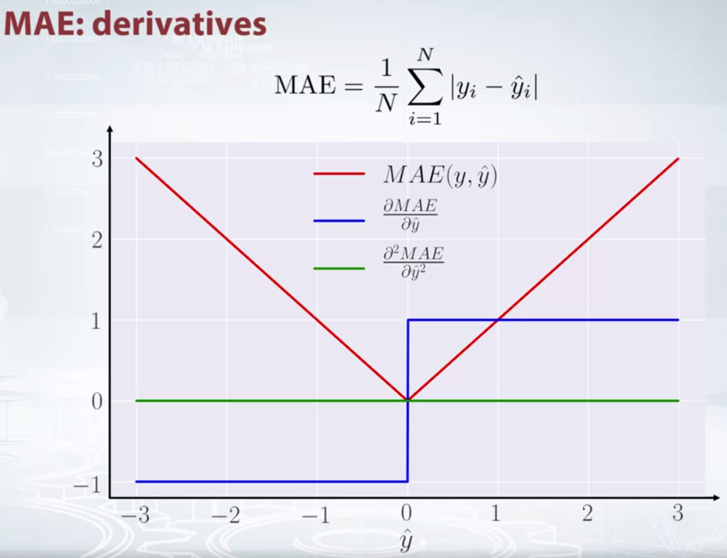

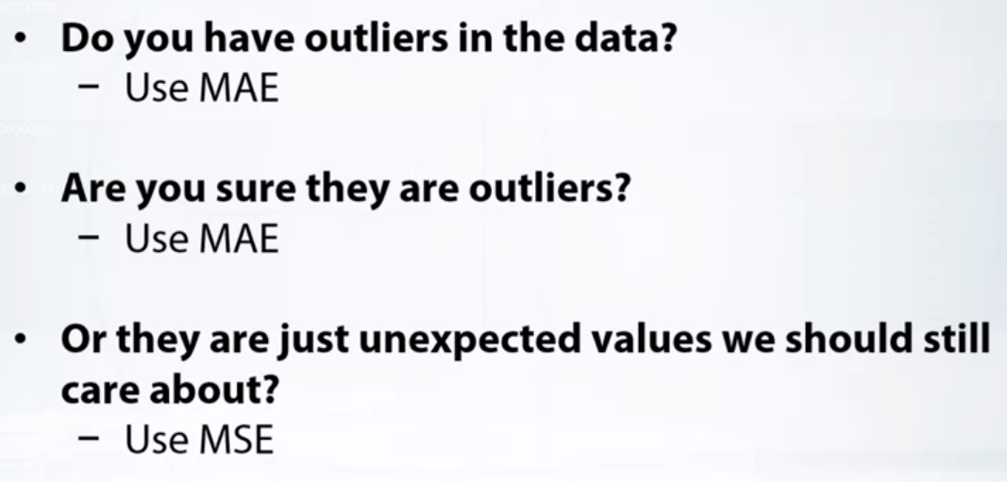

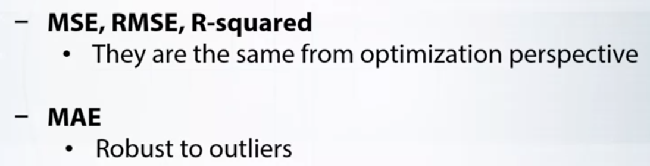

**MSPE and MAPE**

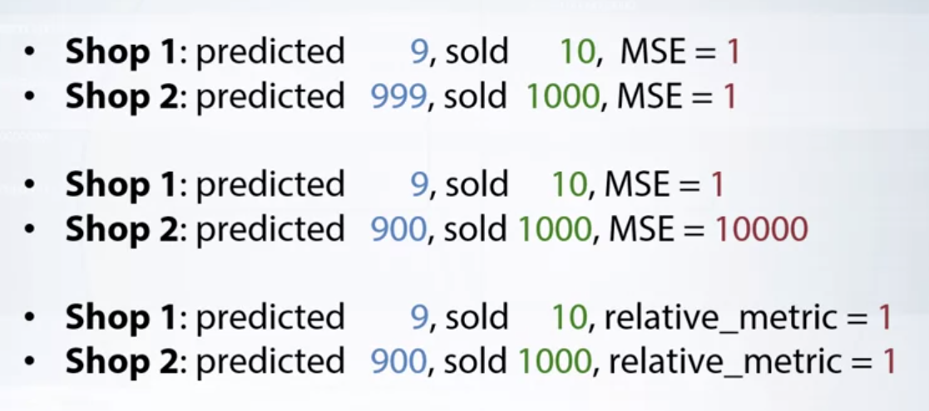

As in the above condition we can see that MSE and RMSE cares only about the absolute difference.

**And not how shop one gave 1 error in only 10 total predictions, whereas shop 2 gave only 1 error in**

**Massive 1000 prediction.** This is not taken care of in MSR/RMSE and so if we can incorporate percentage here it’ll be much better.

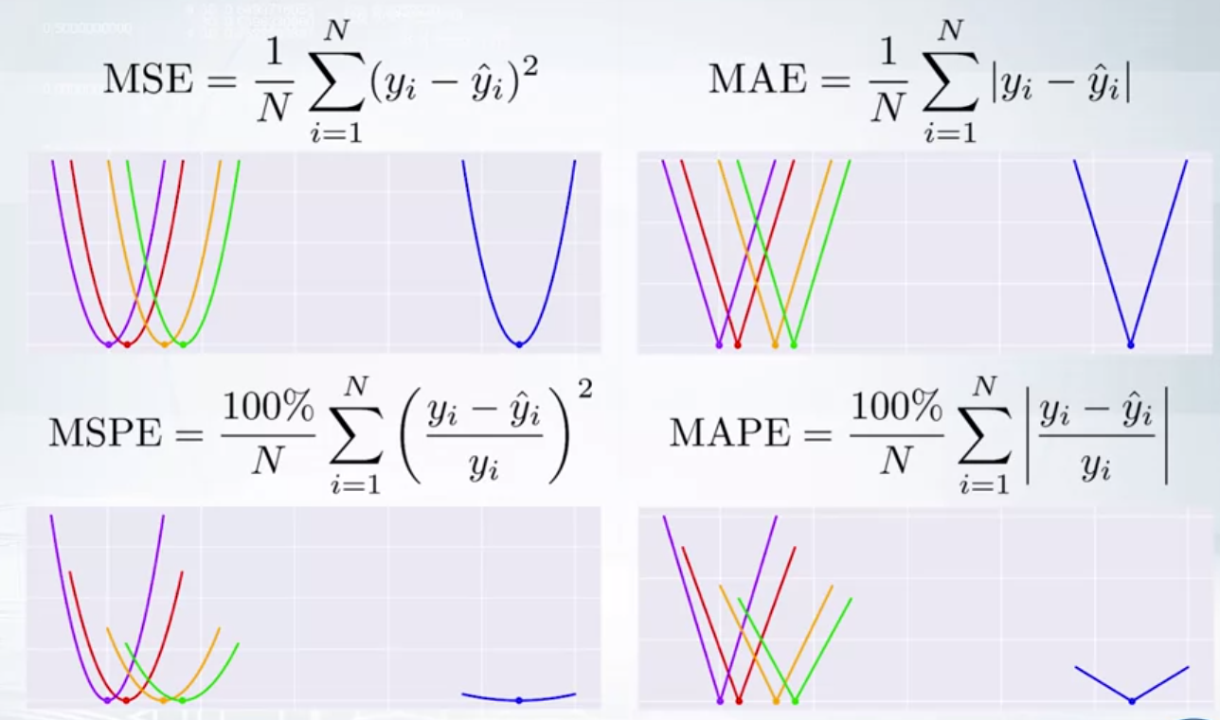

For MSPE and MAPE the constants are the same. As these are just the weighted versions of MSE and MAE.

**MSPE and MAPE can also be thought as weighted versions of MSE and MAE, respectively.**

**For the MAPE, the weight of its sample is inversely proportional to it's target. While for MSPE, it is inversely proportional to a target square. Know that the weight do not sum up to one here.**

**You can take a look at this individual error plus for our individual sample dataset. Now, we see the course became more flat as the target value increases. It means that, the cost we pay for a fixed absolute error, depends on the target value. And as the target increases, we pay less. Example the change of 1 in target 10 and predicted 9 and the change of 1 in target 100 and predicted 99. As target increased the error becomes less.**

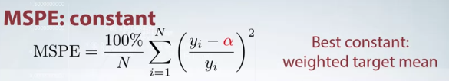

RMSLE root mean square log error

It is just error calculated in logarithmic terms.

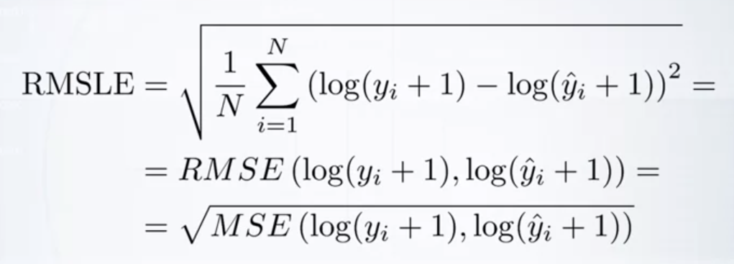

1 is added to make sure log doesn’t equate to zero mostly. The constant can also chose to be different one..

This also cares about relative error more than the absolute error like MSPE and MAPE.

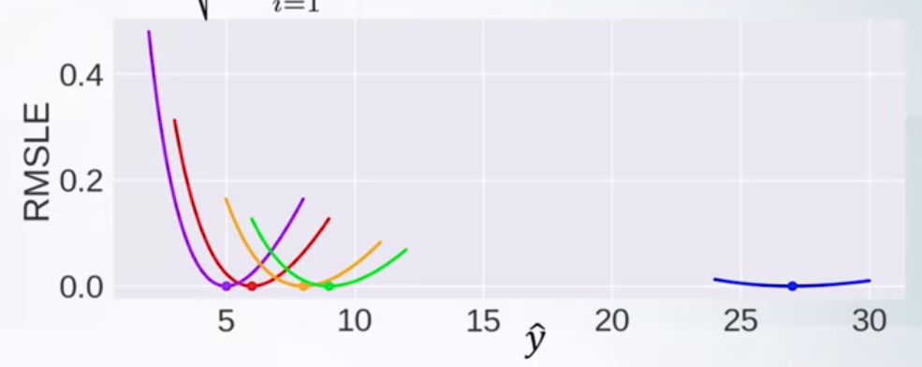

Due to this asymmetry in shape it is always better to create error by predicting more than by predicting less than the target value.

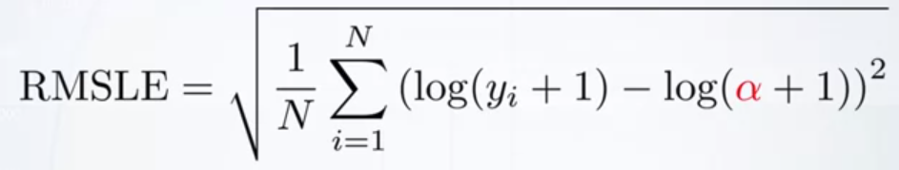

MSE is quite biased towards the huge value from our dataset, while MAE is much less biased.MSPE and MAPE are biased towards smaller targets because they assign higher weight to the object with small targets. And RMSLE is frequently considered as better metrics than MAPE, since it is less biased towards small targets, yet works with relative errors. I strongly encourage you to think about the baseline for metrics that you can face for the first time.

-----------------------------------------------------------------------------------------------------------------

CLASSIFICATION METRICS

Soft predictions - prediction scores of the whole vector

Hard labels - defining exact class based on threshold value

Accuracy:

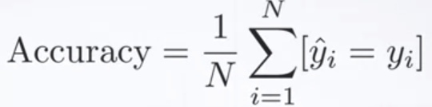

To define accuracy we need hard labels and have to specifically define y hat first.

What is the best constant for the prediction value to assign ? the class having the most frequent class. Accuracy is not the right metric. It doesnt take care of soft metrics.

Logloss:

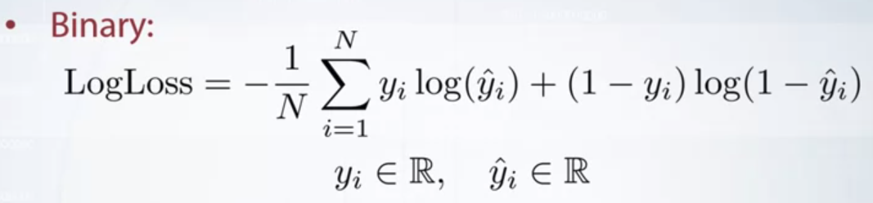

Here y hat ith is a vector of size L, and its sum is exactly 1. The elements are the probabilities to belong to each of the classes.

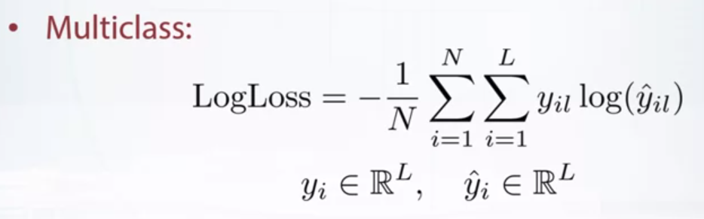

And finally, it should be mentioned that to avoid in practice, predictions are clipped to be not from 0 to 1, but from some small positive number to 1 minus some small positive number.

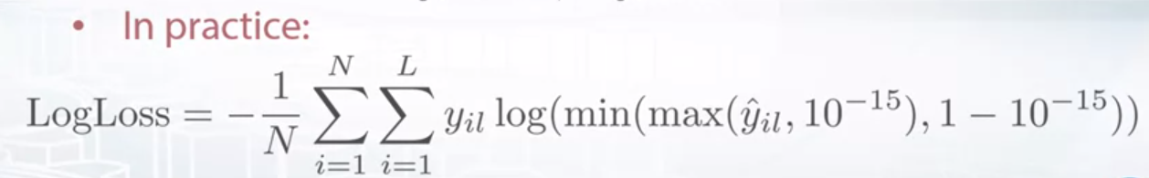

Log loss strongly penalizes completely wrong answers.

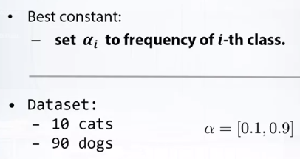

**AREA UNDER CURVE:**

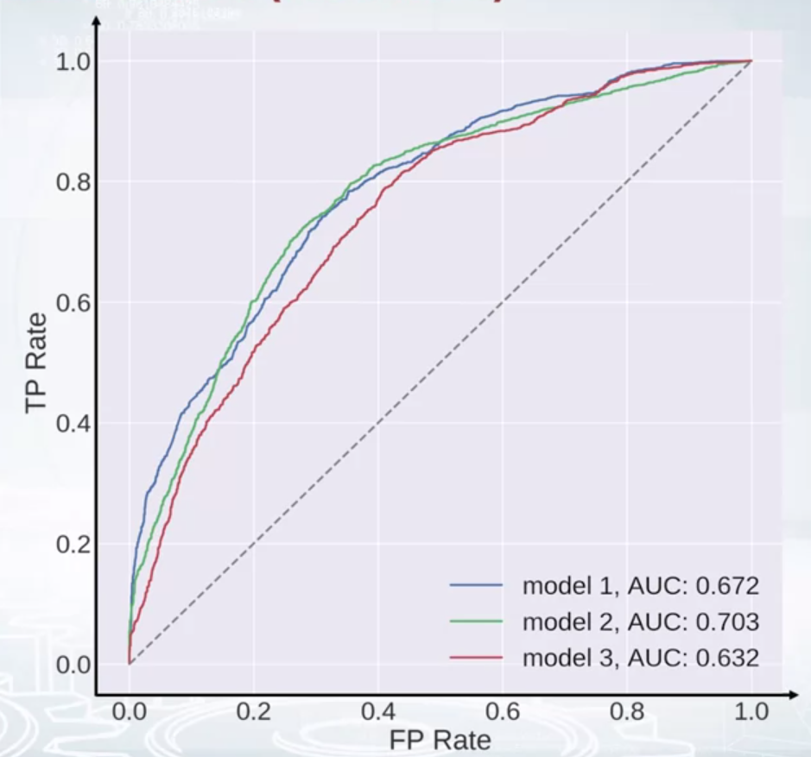

Here curves for different classifiers are shown with different colors. The curves usually lie above the dashed line which shows how would the curve look like if we made predictions at random. So it kind of shows us a baseline. And note that the area under the dashed line is 0.5.

Max AUC value possible is 1

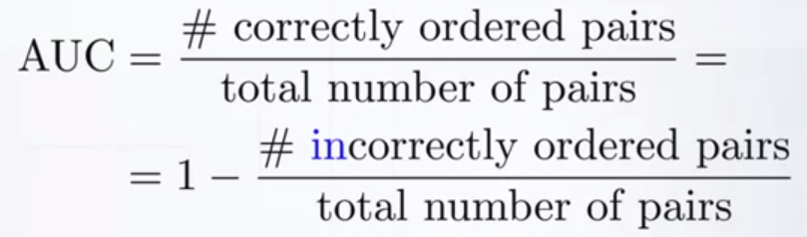

Auc doesnt care about the exact values of the predictions.

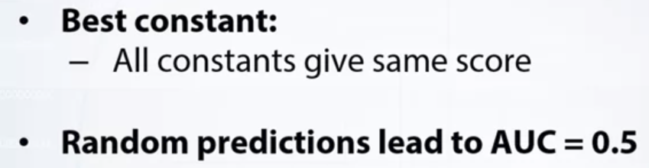

**Cohens Kappa:**

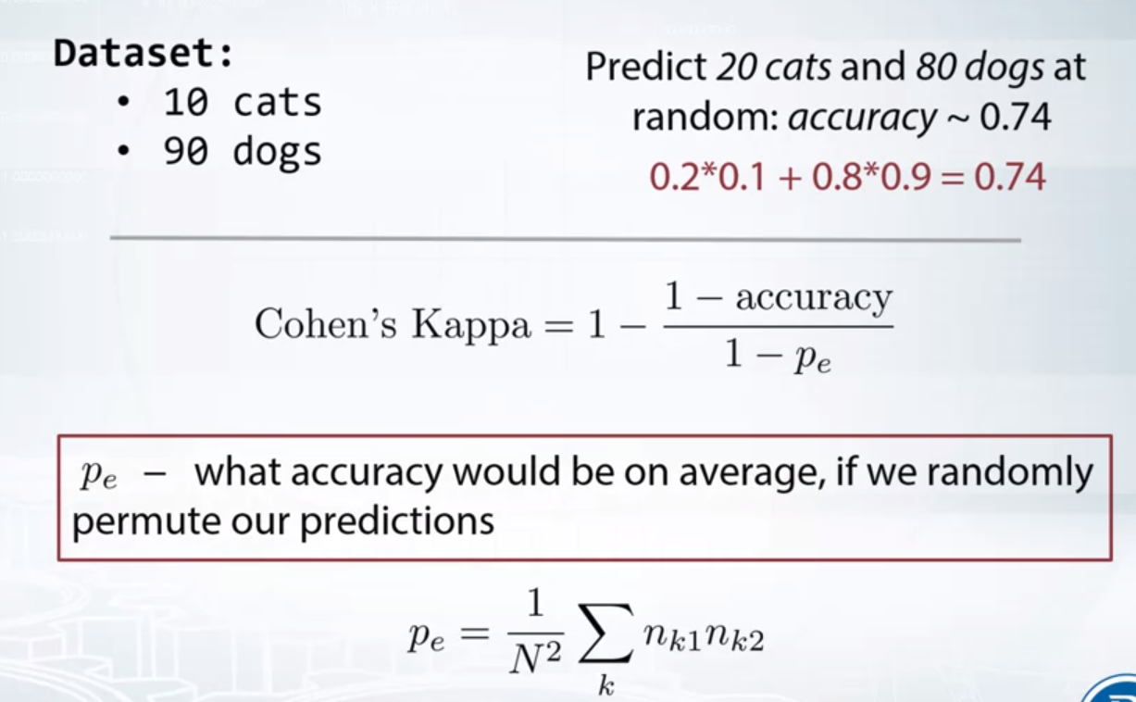

Baseline Pe is computed again and again and taken average.

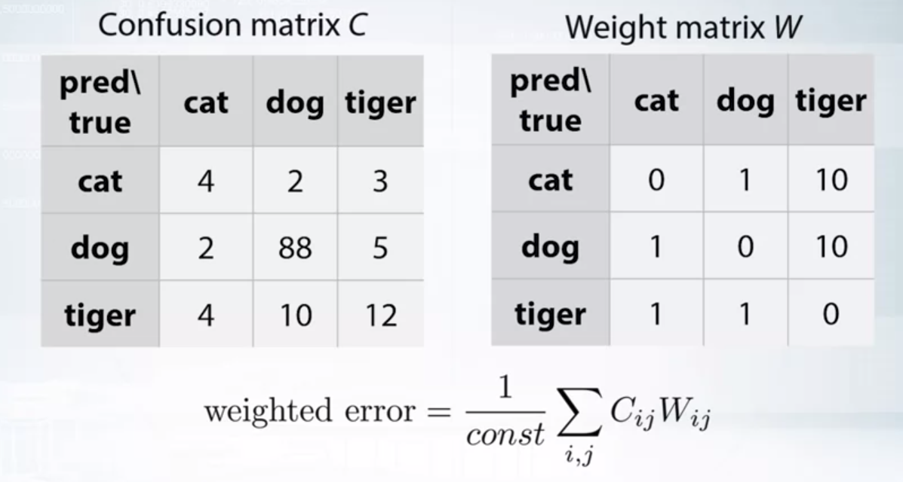

THe weight matrix W as we can see gives an error value of 10 if error in tiger prediction but for others its 1. We try to penalize more for tiger than others.

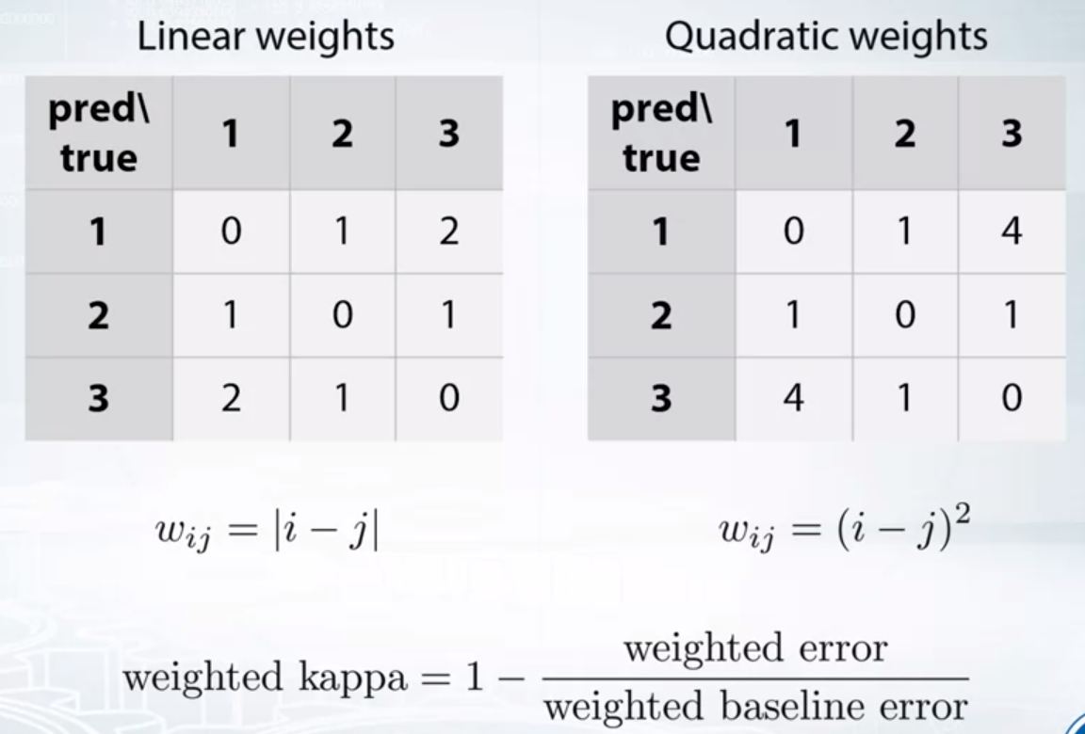

Finally we have linear and quad weight kappa. Different comp uses different version of weighted kappa.

In quadratic weights we pay more if the difference is greater than in linear weights.

The accuracy, it is an essential metric for classification. But a simple model that predicts always the same value can possibly have a very high accuracy that makes it hard to interpret this metric.The score also depends on the threshold we choose to convert soft predictions to hard labels.Logloss is another metric, as opposed to accuracy it depends on soft predictions rather than on hard labels. And it forces the model to predict probabilities of an object to belong to each class.AUC, area under receiver operating curve, doesn't depend on the absolute values predicted by the classifier, but only considers the ordering of the object.

It also implicitly tries all the thresholds to converge soft predictions to hard labels, and thus removes the dependence of the score on the threshold.

Finally, Cohen's Kappa fixes the baseline for accuracy score to be zero. In spirit it is very similar to how R-squared beta scales MSE value to be easier explained.

If instead of accuracy we used weighted accuracy, we would get weighted kappa. Weighted kappa with quadratic weights is called quadratic weighted kappa and commonly used on Kaggle.

____________________________________________________________________

**LOSS vs METRIC**

The metric or target metric is a function which we want to use to evaluate the quality of our model. For example, for a classification task, we may want to maximize accuracy of our predictions, how frequently the model outputs the correct label. But the problem is that no one really knows how to optimize accuracy efficiently. Instead, people come up with the proxy loss functions. They are such evaluation functions that are easy to optimize for a given model. For example, logarithmic loss is widely used as an optimization loss, while the accuracy score is how the solution is eventually evaluated. So, once again, the loss function is a function that our model optimizes and uses to evaluate the solution, and the target metric is how we want the solution to be evaluated.

Sometimes loss function and the target metric are taken the same.

LOSS function is for the model

METRIC is for us to judge

**METRIC**

MSE

LOGLOSS

Both are the most common and are also implemented as loss functions in almost every library.

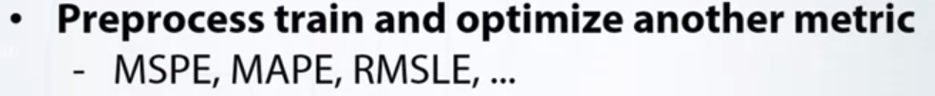

For example, while MSPE metric cannot be optimized directly with XGBoost, we will see later that we can resample the train set and optimize MSE loss instead, which XGBoost can optimize.

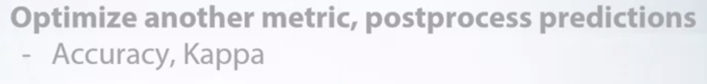

Sometimes, we'll optimize incorrect metric, but we'll post-process the predictions to fit classification, to fit the metric better.

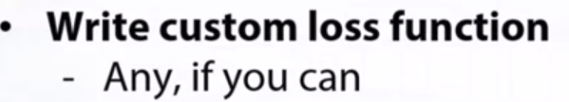

For some models and frameworks, it's possible to define a custom loss function, and sometimes it's possible to implement a loss function which will serve as a nice proxy for the desired metric.

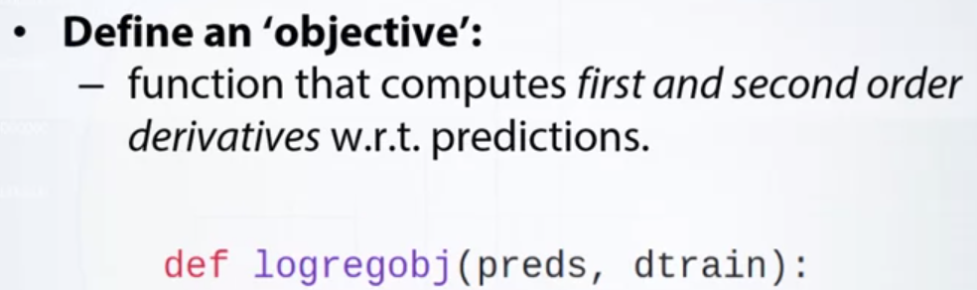

One method that always works is

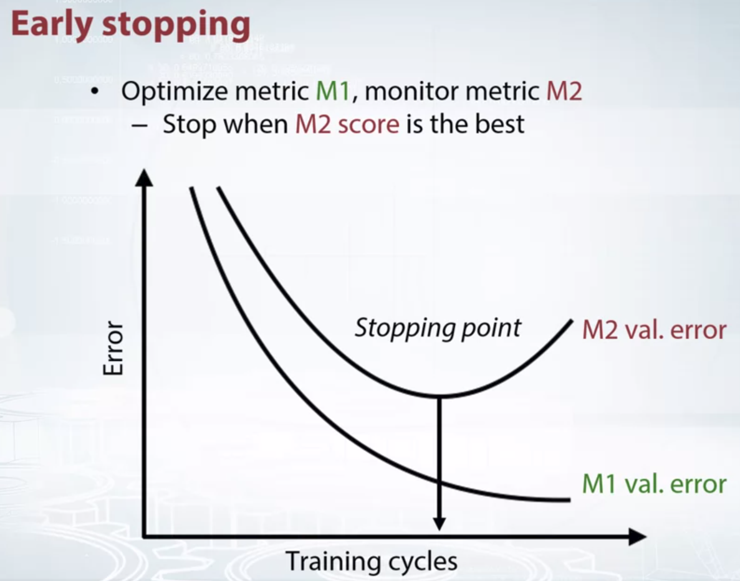

______________________________________________________________________

OPTIMIZING REGRESSION METRICS

RMSE MSE R-Squared is supported by all

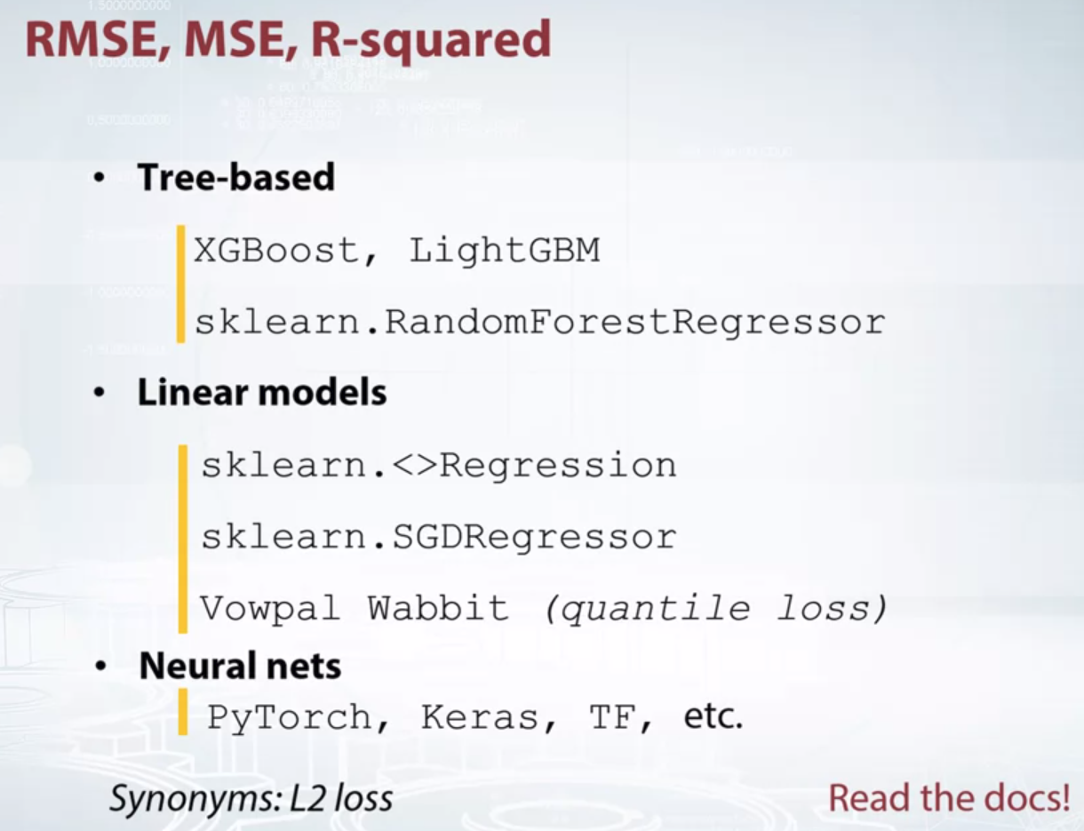

For optimizing MAE

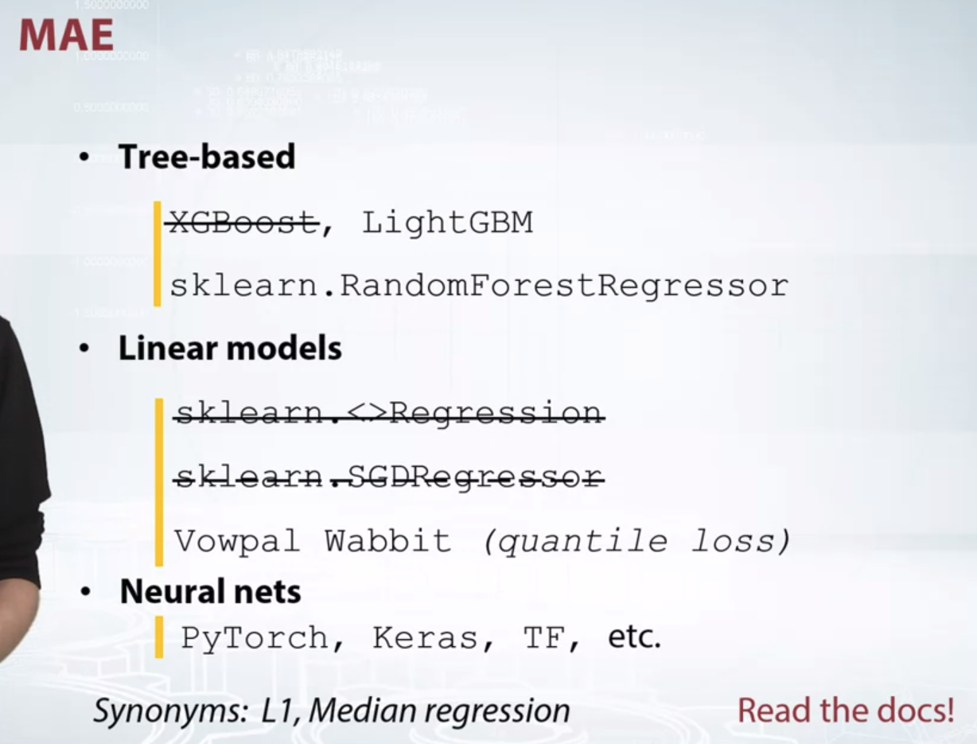

a lot of ways to make MAE smooth. You can actually make up your own smooth function that have upload that loops like MAE error. The most famous one is Huber loss. It's basically a mix between MSE and MAE.

MSE is computed when the error is small, so we can safely approach zero error. And MAE is computed for large errors given robustness.

AS you can see in the plot

MSE

MAE and

Huber curves

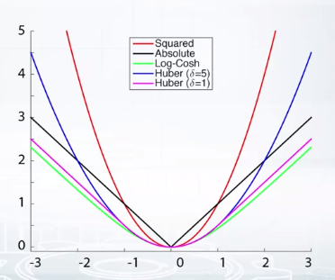

**MSPE AND MAPE**

MSPE and MAPE. It's much harder to find the model which can optimize them out of the box. Of course we can always can use, either, of course we can always either implement a custom loss for an integer boost or a neural net. It is really easy to do there. Or we can optimize different metric and do early stopping.

But there are several specific approaches

This approach is based on the fact that MSP is a weighted version of MSE and MAP is a weighted version of MAE.

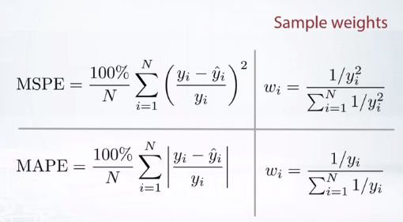

The summon denominator just ensures that the weights are summed up to 1, but it's not required.

6:10

Intuitively, the sample weights are indicating how important the object is for us while training the model.

6:19

The smaller the target, is the more important the object. That is why for smaller values bigger weight value and so the values are inverse here. And denominator to sum upto one.

So, how do we use this knowledge?

6:28

In fact, many libraries accept sample weights.

6:31

Say we want to optimize MSP.

6:34

So if we can set sample weights to the ones from the previous slide,

6:39

we can use MSE laws with it.

6:43

And, the model will actually optimize desired MSPE loss. Although most important libraries like XGBoost, LightGBM, most neural net packages support sample weighting, not every library implements it.

But there is another method which works whenever a library can optimize MSE or MAE. Nothing else is needed.

All we need to do is to create a new training set by sampling it from the original set that we have and fit a model with, for example, I'm a secretarian if you want to optimize MSPE.

It is important to set the probabilities for each object to be sampled to the weights we've calculated.

The size of the new data set is up to you. You can sample for example, twice as many objects as it was in the original train set.

And note that we do not need to do anything with the test set. It stays as is.

I would also advise you to re-sample train set several times. Each time fitting a model. And then average models predictions, if we'll get the score much better and more stable.

The results will, another way we can optimize MSPE,

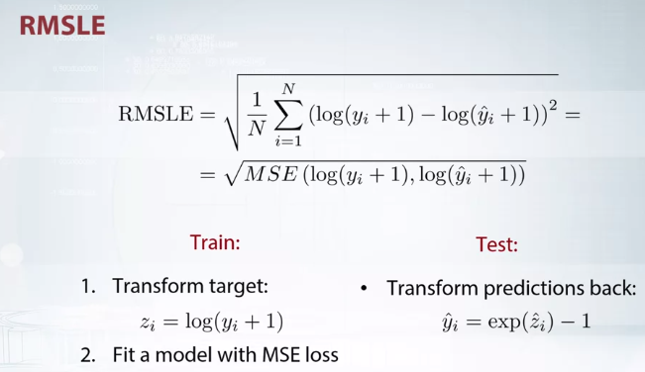

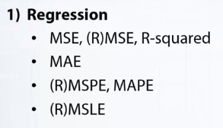

In this video, we run through regression matrix and tools to optimize them. MSE and MAE are very common and implemented in many packages. RMSPE and MAPE can be optimized by either resampling the data set or setting proper sample weights. RMSLE is optimized by optimizing MSE in log space.

________________________________________________________________________________

**CLASSIFICATION METRICS OPTIMIZED**

* LOG LOSS
* ACCURACY
* AUC
* KAPPA

Log loss is very common and implemented in all models out of the box.

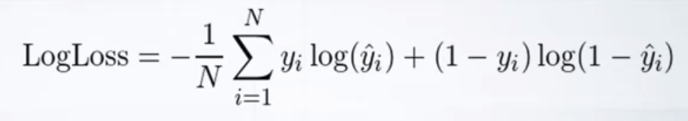

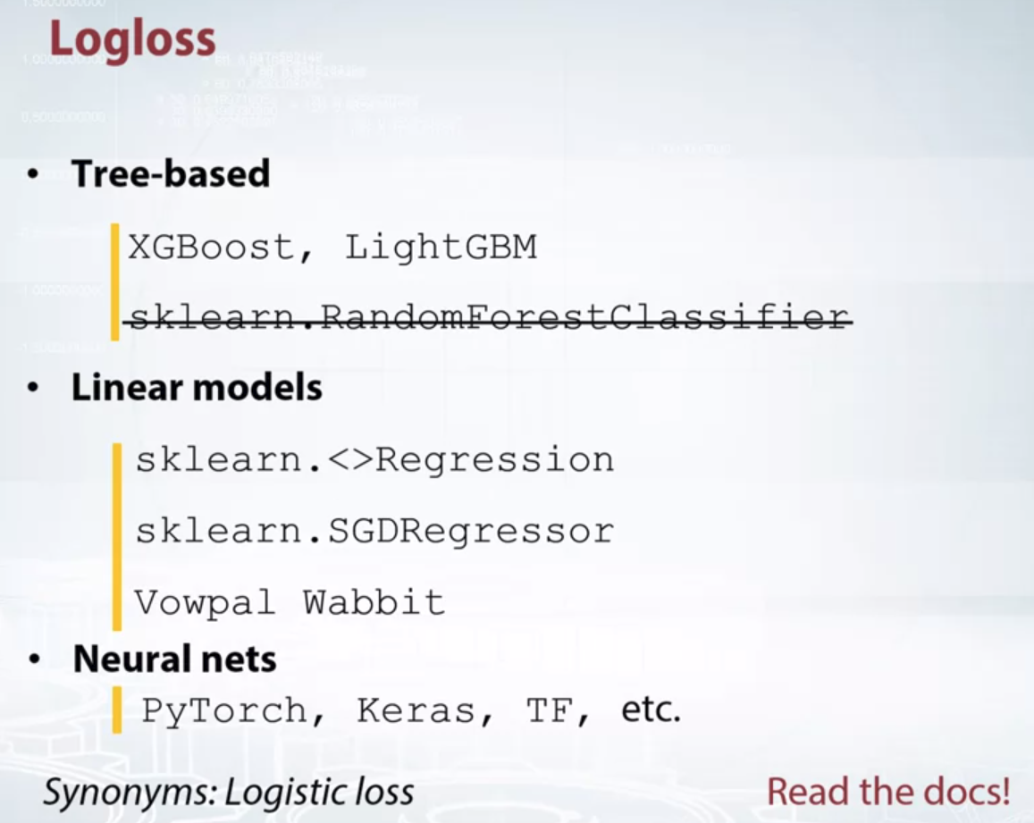Random forest classifier predictions turn out to be quite bad in terms of logloss. But there is a way to make them better, we can calibrate the predictions to better fit logloss.

In other words, in the regression setting, distance matters. And since the distance between two points is intrinsically closely tied to the probability that those two points are "close" to one another, the machine learning algorithms used for regression tend to have reasonably accurate probability estimates.

The same is not true of classification. In classification we use (and algorithms optimize for) all-or-nothing cost functions and metrics. For example, accuracy only measures how often we are correct, and says nothing about how *confident* we are in being correct. Meanwhile, Gini inequality, used by decisions trees, optimizes for taking the biggest strides *towards* being as correct as possible. This is because in classification tasks there is intrinsically no such thing as "distance". It doesn't make sense to say that the distance between a photo of a bumblebee and a photo of a honey bee is 5, at least not in the same way that it makes sense to say that the distance between the price of this one-bedroom AirBnB and the median price of an average one-bedroom AirBnB in the same neighborhood is $50 (for certain problems [error-correcting output codes](https://www.kaggle.com/residentmario/notes-on-multiclass-and-multitask-schemes) seem like an interesting approach to this, though).

As a result, classification algorithms tend to have much weaker and more systematically biased probability prediction forecasts. For settings in which only the class being assigned matters, and we do not care about how confident we are in that assignment being correct, this is fine. If we *do* care about our confidence (for example, we are competing in a Kaggle competition whose metric is [log-loss](https://www.kaggle.com/residentmario/log-loss-with-new-york-city-building-sales/)), this is a major problem. As in log loss along with the prediction we also have to tell how much we are confident for that prediction, which is very important. So the better the prediction to actual 1 and 0 the better the final score.

<https://www.kaggle.com/residentmario/notes-on-classification-probability-calibration>

Blog which gave the above explanation and also has good code explanation

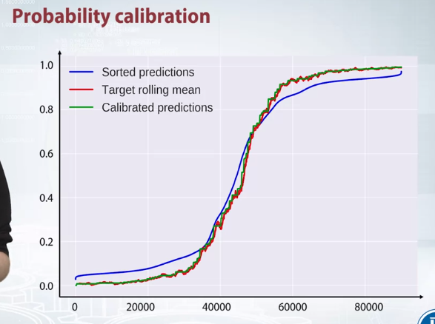

Take a look at this plot, the blue line shows sorted by value predictions for the validation set. And the red line shows correspondent target values smoothed with rolling window. We clearly see that our predictions are kind of conservative. They´re much greater than two target mean on the left side, and much lower than they should be on the right side.

So this classifier is not calibrated, and the green curve shows the predictions after calibration.

But if we plot sorted predictions for calibrated classifier, the curve will be very similar to target rolling mean. And in fact, the calibrator predictions will have lower log loss.

Now, there are several ways to calibrate predictions, for example,

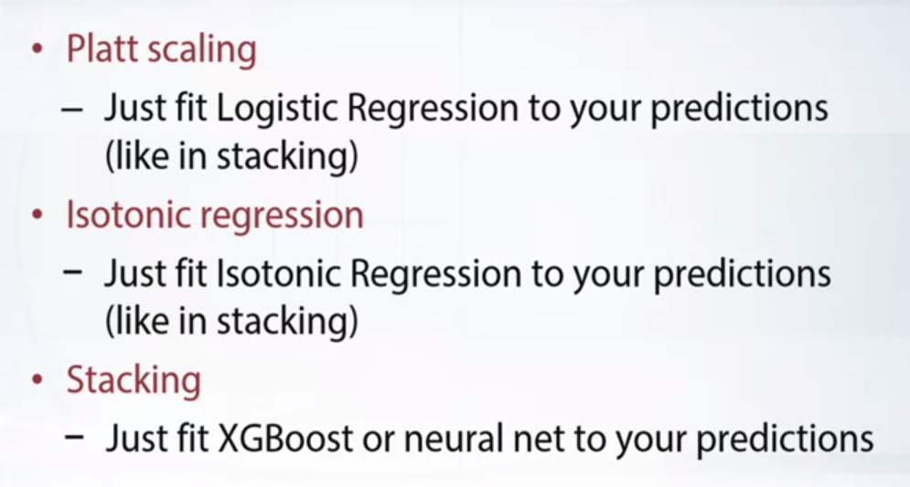

While finally, we can use stacking, so the idea is, we can fit any classifier. It doesn't need to optimize logloss, it just needs to be good, for example, in terms of AUC.

And then we can fit another model on top

that will take the predictions of our model, and calibrate them properly. And that model on top will use logloss as its optimization loss. So it will be optimizing indirectly, and its predictions will be calibrated.

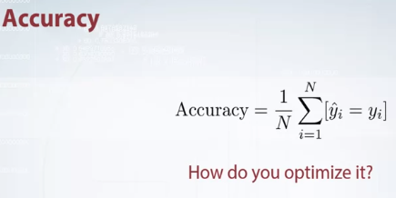

Logloss was the only metric that is easy to optimize directly. With accuracy, there is no easy recipe how to directly optimize it. In general, the recipe is following, actually, if it is a binary classification task, fit any metric, and tune with the binarization threshold. For multi-class tasks, fit any metric and tune parameters comparing the models by their accuracy score, not by the metric that the models were really optimizing.

So this is kind of early stopping and the cross validation, where you look at the accuracy score.

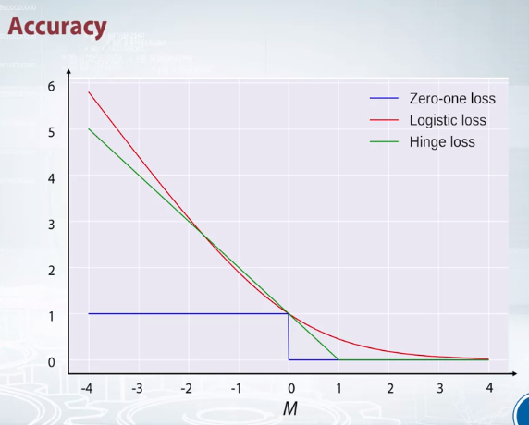

Just to get an intuition why accuracy is hard to optimize, let's look at this plot.

So on the vertical axis we will show the loss, and the horizontal axis shows signed distance to the decision boundary, for example, to a hyper plane or for a linear model. The distance is considered to be positive if the class is predicted correctly. And negative if the object is located at the wrong side of the decision boundary.

The blue line here shows zero-one loss, this is the loss that corresponds to accuracy score. We pay 1 if the object is misclassified, that is, the object has negative distance, and we pay nothing otherwise.

The problem is that, this loss has zero almost everywhere gradient, with respect to the predictions. As the line is horizontal as compared to all the other lines where we can find the slope and then back prop to it . And most learning algorithms require a nonzero gradient to fit, otherwise it's not clear how we need to change the predictions such that loss is decreased.

And so people came up with proxy losses

that are upper bounds for these zero-one loss. So if you perfectly fit the proxy loss, the accuracy will be perfect too,

but differently to zero-one loss, they are differentiable. For example, you see here logistic loss, the red curve used in logistic regression, and hinge loss, loss used in SVM.

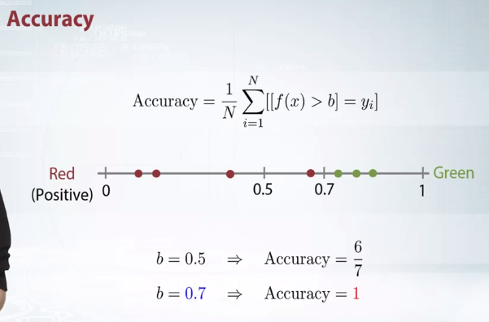

Now recall that to obtain hard labels for a test object, we usually take argmax of our soft predictions, picking the class with a maximum score. If our task is binary and soft predictions sum up to 1, argmax is equivalent to threshold function. Output 1 when the predictions for the class one is higher than 0.5, and output 0 when the prediction's lower.

So we've already seen this example where threshold 0.5 is not optimal,

so what can we do? We can tune the threshold we apply, we can do it with a simple grid search implemented with a for loop. Well, it means that we can basically fit any sufficiently powerful model. It will not matter much what loss exactly, say, hinge or log loss the model will optimize. All we want from our model's predictions is the existence of a good threshold that will separate the classes.

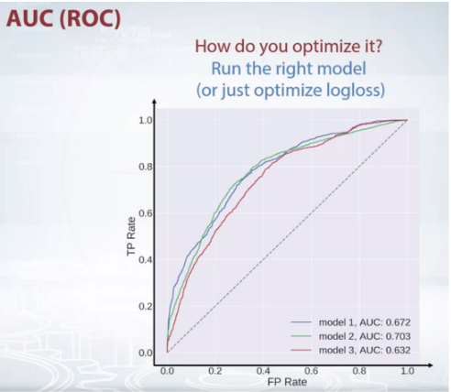

TPR is percentage of positives detected out of all the actual positives.

An excellent model has AUC near to the 1 which means it has good measure of separability. A poor model has AUC near to the 0 which means it has worst measure of separability. In fact it means it is reciprocating the result. It is predicting 0s as 1s and 1s as 0s. And when AUC is 0.5, it means model has no class separation capacity whatsoever.

Sensitivity and Specificity are inversely proportional to each other. So when we increase Sensitivity, Specificity decreases and vice versa.

*Sensitivity⬆️, Specificity⬇️ and Sensitivity⬇️, Specificity⬆️*

When we decrease the threshold, we get more positive values thus it increases the sensitivity and decreasing the specificity.

Similarly, when we increase the threshold, we get more negative values thus we get higher specificity and lower sensitivity.

As we know FPR is 1 - specificity. So when we increase TPR, FPR also increases and vice versa.

*TPR⬆️, FPR⬆️ and TPR⬇️, FPR⬇️*



<https://www.youtube.com/watch?v=gYIlKUP2hk0> a good AUC explaination video.

XGBoost, LightGBM have pairwise loss implemented which can be used for AUC. I should say that in practice,

most people still use logloss as an optimization loss without any more post processing.

I personally observed XGBoost learned with logloss to give

comparable AUC score to the one learned with pairwise loss.

**QUAD WEIGHTED KAPPA**

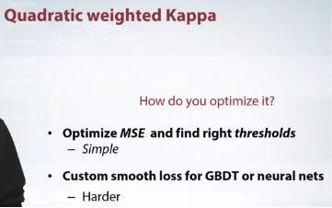

COHENS KAPPA

OA – Observed agreement

AC – Agreement by chance

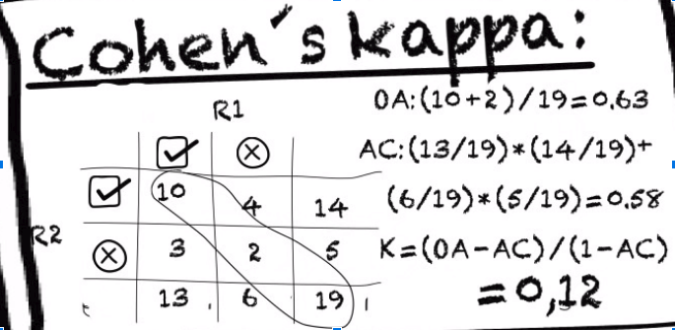

A nice youtube video snippent defining Cohens Kappa

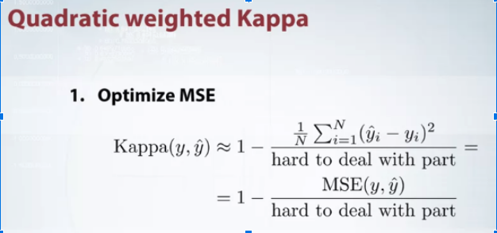

But let's start with the simple one.

Recall that we're solving

an ordered classification problem and our labels can be found of us integer ratings,

say from one to five.

The task is classification as we cannot output,

for example, 4.5 as an answer.

But anyway, we can treat it as a regression problem, and then somehow,

post-process the predictions and convert them to integer ratings.

And actually quadratic weights make Kappa as somehow similar to regression with MSE loss.

If we allow our predictions to take values between the labels,

that is relax the predictions.

But in fact, it is different to MSE.

So if relaxed, Kappa would be

one minus MSE divided by something that really depends on the predictions.

And it looks like everyone's logic is, well,

there is MSE in the numerator,

we can optimize it,

and let's don't care about denominator.

Well, of course it's not the correct way to do it,

but it turns out to be useful in practice.

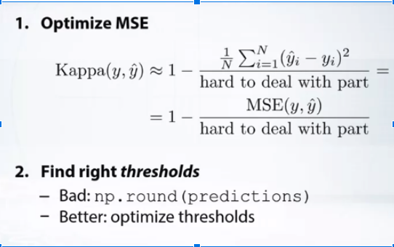

But anyway, MSE gives us flat values instead of integers.

So now, we need somehow to convert them into integers.

And the straightforward way would be to do rounding all the predictions.

But we can think about rounding as of applying a threshold.

Like if the value is greater than 3.5 and less than 4.5, then output 3.

But then we can ask ourselves a question,

why do we use exactly those thresholds? Let's tune them.

And again, it's just straightforward,

it can be easily done with grid search.

So to summarize, we need to fit MSE loss to

our data and then find appropriate thresholds.

**IN BINARY CLASSIFICATION WE HAVE LOG TO THE BASE E ln**

**QUIZ**

What would be a logloss value for a binary classification task, if we use constant predictor f(x) = 0.5? Round to two decimal places.

**IN BINARY CLASSIFICATION WE HAVE LOG TO THE BASE E ln**

THIS IS -LN(0.5) = 0.69

The best constant predictor for MAE metric is



Target median

Target 50-th percentile

The best constant predictor for mean squared error is



Target mean



Average of the target vector

The best constant prediction for AUC is



Any constant will lead to the same AUC value

Suppose the target metric is R-squared. What optimization loss should we use for our models?



RMSE



MSE

Calculate AUC for these predictions:

import numpy as np

from sklearn.metrics import roc_auc_score

y_true = np.array([1, 0, 1, 1, 1, 0, 0])

y_scores = np.array([0.39, 0.52, 0.91, 0.85, 0.49, 0.02, 0.44])

roc_auc_score(y_true, y_scores)

0.75

QUIZ

# Question 1

## Suppose we solve a binary classification task and our solution is scores with logloss. What predictions are more preferable in terms of logloss if true labels are y_true = [0, 0, 0, 0].

Correct answers:

* y_pred = [0.5, 0.5, 0.5, 0.5].

Incorrect answers:

* y_pred = [0, 0, 0, 1]. Incorrect! Technically, the loss is infinite in this case, while is it is not for other options, so it cannot be the right answer.
* y_pred = [0.4, 0.5, 0.5, 0.6]. Incorrect! What is better to predict [0.5, 0.5] or [0.4, 0.6]? To answer this question think how
* \log
* logfunction behaves. If you plot it you will clearly see that
* \log(6) - \log(5) < log(5) - log(4)
* log(6)−log(5)<*log*(5)−*log*(4), thus
* log(4) + log(6) < log(5) + log(5)
* *log*(4)+*log*(6)<*log*(5)+*log*(5). In fact it follows from [Jensen's inequality](https://en.wikipedia.org/wiki/Jensen%27s_inequality).

# Question 2

## Suppose we solve a regression task and we optimize MSE error. If we managed to lower down MSE loss on either train set or test set, how did we change Pearson correlation coefficient between target vector and the predictions on the same set?

Correct answers:

* Any behavior is possible. Yes! We cannot monotonically relate MSE and Pearson correlation similarly to how e.g. R-squared monotonically related MSE,

Incorrect answers:

* The correlation did not change. Try to come up with a counterexample when correlation is zero, but MSE can be lowered down.
* The correlation was also lowered. No! Try to come up with a counterexample when correlation is zero, but MSE can be lowered down.
* The correlation became larger.

# Question 3

## What would be a best constant prediction for a following multiclass classification task with 4 classes? The number of objects of each class in train set is: 18, 3, 15, 24. Enter four comma separated values. Round each to two decimal places.

Correct answer:

* 0.3,0.05,0.25,0.4. To compute the best constant prediction for multi-logloss we need to divide number of objects in each class by the total size of the dataset. E.g. 18/(18 + 3 + 5 + 24) = 0.3 .

# Question 4

## What is the best constant predictor for R-squared metric?

Correct answers:

* Target mean. Yes! As it is up to a constant is equal to MSE metric.

Incorrect answers:

* One minus target mean. No! Well, maybe when the target mean is 0.5 this will work out :)
* Target mean divided by target variance. No! It's hard to justify this answer.
* (Log of target mean) + 1. No, this option would be true if the question asked about RMSLE metric.
* 0.5. Does not depend on data at all?..

# Question 5

## Select the correct statements.

Correct answers:

* Optimization loss can be the same as target metric. Yes! Sometimes we can use target metric as optimization loss. For example if our target metric is MSE.
* Optimization loss can different to target metric. Yes! Sometimes we cannot use target metric as optimization loss. For example if our target metric is accuracy.

Incorrect answers:

* Optimization loss is always different to target metric.
* Optimization loss is always the same as target metric.

# Question 6

## Suppose the target metric is M1, and optimization loss is M2. We train a model and monitor its quality on a *holdout set* using metrics M1 and M2. Select the correct statements.

Correct answers:

* There is no definite relation between the best iterations for M1 score and M2 score.

Incorrect answers:

* If the best M1 score is attained at iteration N, then the best M2 score is always attained after N-th iteration.
* If the best M1 score is attained at iteration N, then the best M2 score is always attained before N-th iteration.
* If the best M1 score is attained at iteration N, then the best M2 score is always attained also at the iteration N. No! It is not true in general. There are exceptions though. For example if M1 is MSE and M2 is R-squared.

______________________________________________________________________

ADDITIONAL MATERIAL

# Classification

* [Evaluation Metrics for Classification Problems: Quick Examples + References](http://queirozf.com/entries/evaluation-metrics-for-classification-quick-examples-references)

ABOVE LINK HAS EVALUATION METRICS EXPLAINED. SIMPLE ONES AND WHERE TO USE THEM MOSTLY FOR.

# Decision Trees: “Gini” vs. “Entropy” criteria

The scikit-learn documentation[1](https://www.garysieling.com/blog/sklearn-gini-vs-entropy-criteria#footnote_0_2094) has an argument to control how the decision tree algorithm splits nodes:

* criterion : string, optional (default=”gini”)
* The function to measure the quality of a split.
* Supported criteria are “gini” for the Gini impurity
* and “entropy” for the information gain.

It seems like something that could be important since this determines the formula used to partition your dataset at each point in the dataset.

Unfortunately the documentation tells you nothing about what you should use, other than trying each to see what happens, so here’s what I found (spoiler: it doesn’t appear to matter):

* Gini is intended for continuous attributes, and Entropy for attributes that occur in classes (e.g. colors[2](https://www.garysieling.com/blog/sklearn-gini-vs-entropy-criteria#footnote_1_2094)
* “Gini” will tend to find the largest class, and “entropy” tends to find groups of classes that make up ~50% of the data((http://paginas.fe.up.pt/~ec/files_1011/week%2008%20-%20Decision%20Trees.pdf))
* “Gini” to minimize misclassification[3](https://www.garysieling.com/blog/sklearn-gini-vs-entropy-criteria#footnote_2_2094)
* “Entropy” for exploratory analysis[4](https://www.garysieling.com/blog/sklearn-gini-vs-entropy-criteria#footnote_3_2094)
* Some studies show this doesn’t matter – these differ less than 2% of the time[5](https://www.garysieling.com/blog/sklearn-gini-vs-entropy-criteria#footnote_4_2094)
* Entropy may be a little slower to compute[6](https://www.garysieling.com/blog/sklearn-gini-vs-entropy-criteria#footnote_5_2094)

__________________________________________________________

**CONCEPT OF MEAN ENCODINGS**

To add some variables based on some features together with target.

We encode each categorical label with target mean for those labels.

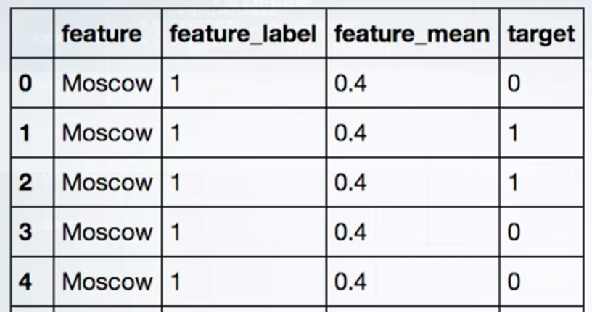

Feature mean made by sum of target / moscow city count = ⅖ = 0.4

Why does it even work? Imagine, that our dataset is much bigger and contains hundreds of different cities. Well, let's try to compare, of course, very abstractly, mean encoding with label encoding.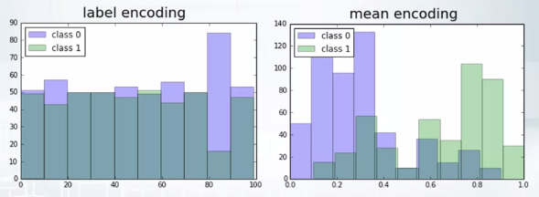

We plot future histograms for class 0 and class 1. In case of label encoding, we'll always get total and random picture because there's no logical order, but when we use mean target to encode the feature, classes look way more separable. The plot looks kind of sorted.

It turns out that this sorting quality of mean encoding is quite helpful. Remember, what is the most popular and effective way to solve machine learning problem? Is grading boosting trees, XGBOOST or LGBM. One of the few downsides is an inability to handle high cardinality categorical variables.

Trees have limited depth, with mean encoding, we can compensate for it,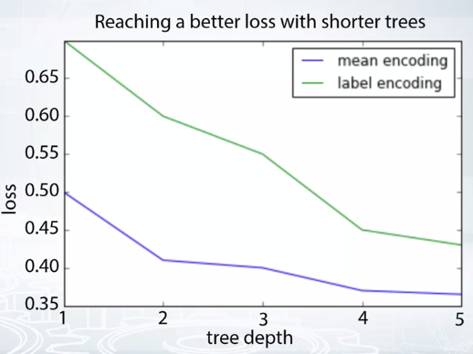

we can reach better loss with shorter trees. Cross validation loss might even look like this.

In general, the more complicated and non linear feature target dependency, the more effective is mean encoding,

**INDICATOR OF USEFULNESS OF MEAN ENCODINGS**

The presence of categorical variables with a lot of levels is already a good indicator, but we need to go a little deeper.

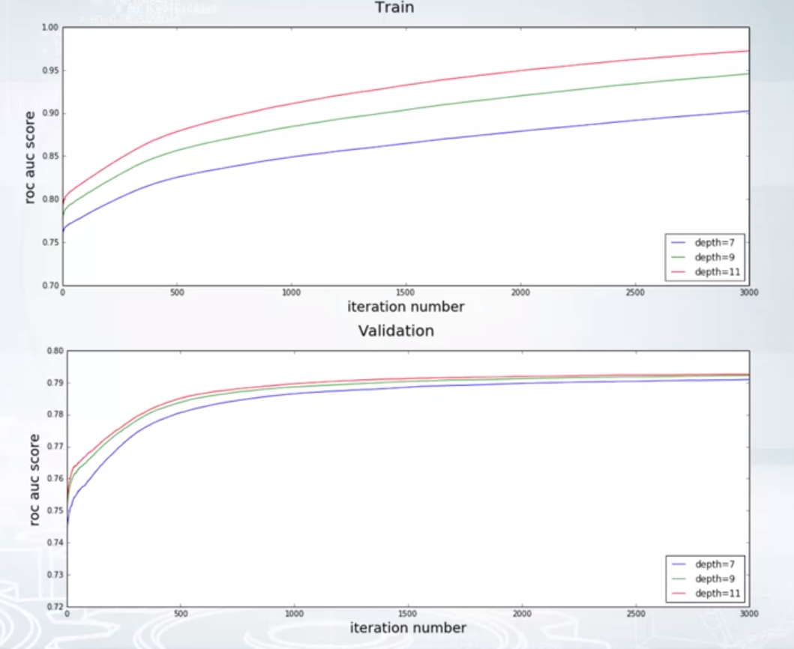

Let's take a look at each of these learning logs from Springleaf competition.

I ran three models with different depths, 7, 9, and 11. Train logs are on the top plot. Validation logs are on the bottom one.

4:28

As you can see, with increasing the depths of trees, our training care becomes better and better, nearly perfect and that's a normal part.

But we don't actually overfit and that's weird. Our validation score also increase, it's a sign that trees need a huge number of splits to extract information from some variables. And we can check it for mortal dump.

It turns out that some features have a tremendous amount of split points, like 1200 or 1600 and that's a lot. Our model tries to treat all those categories differently and they are also very important for predicting the target. We can help our model via mean encodings.

Ways to calculate encodings

1. The one discussed above taking mean of the target based on category.
2. Weight of e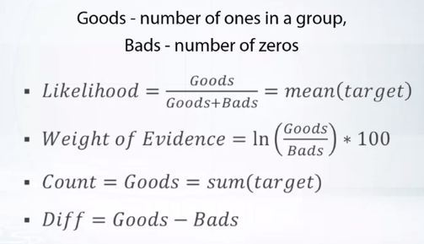

What we have done is taken mean of target or the first likelihood one above.

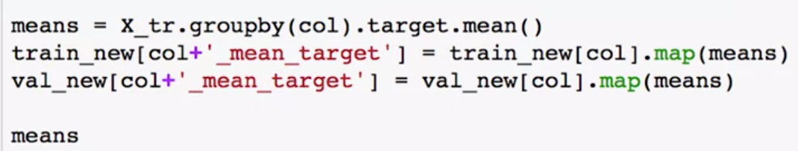

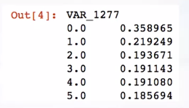

Means is of datatype pandas.Series

Now, let's actually construct the features.

We will do it on spring leaf data set,

suppose we've already separated the data for train and

validation, X_tr and X val data frames.

we can fit each of those model on this new data.

But something's definitely not right,

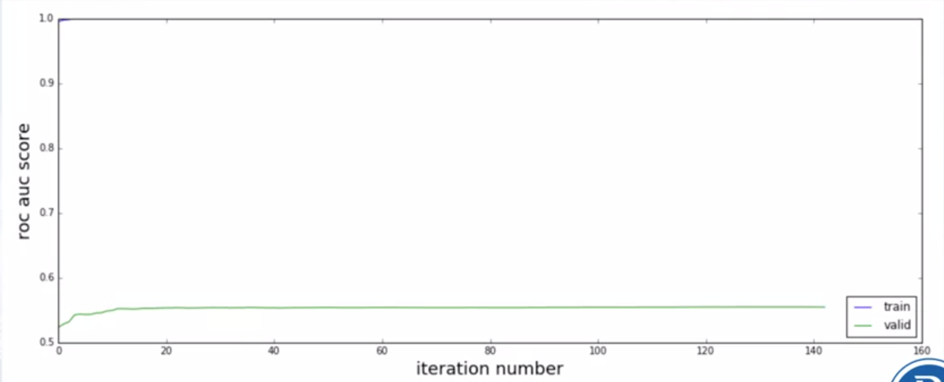

after several efforts training AOC is nearly 1, while on validation,

the score set rates around 0.55, which is practically noise.

Because AUC of 0.5 means random value of pure probability of 0.5.

Means the model don’t know anything about prediction. Less than 0.5 on

AUC is not possible. It ranges from 0.5 to 1

It's a clear sign of terrible overfitting.

I'll explain what happened in a few moments.

Right now, I want to point out that at least we validated correctly.

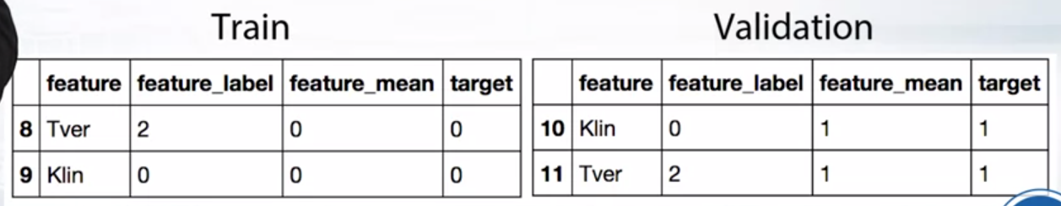

We separated train and

validation, and used all the train data to estimate mean encodings. And used validation data to create its own mean encoding later on.

If, for instance, we would have estimated mean encodings before

train validation split, then we would not notice such an overfitting.

Now, let's figure out the reason of overfitting.

When they are categorized, it's pretty common to get results like in the above image example,

target 0 in train and target 1 in validation.

Mean encodings turns into a perfect feature for such categories.

That's why we immediately get very good scores on train and

fail hardly on validation. Obviously we cannot use mean encodings like this in practice.

We need to deal with over fitting first, we need some kind of regularization.

**REGULARIZATION IN MEAN ENCODING**

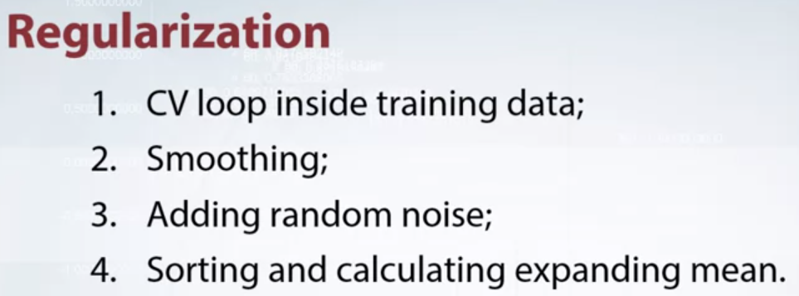

**1 CV loop regularization.**

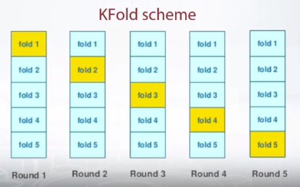

It's a very intuitive and robust method.

For a given data point, we don't want to use target variable of that data point.

So we separate the data into K- folds.

To get mean encoding value for some subset, we don't use data points

from that subset and estimate the encoding only on the rest of subset.

We iteratively walk through all the data subsets.

Usually, four or five folds are enough to get decent results.

You don't need to tune this number.

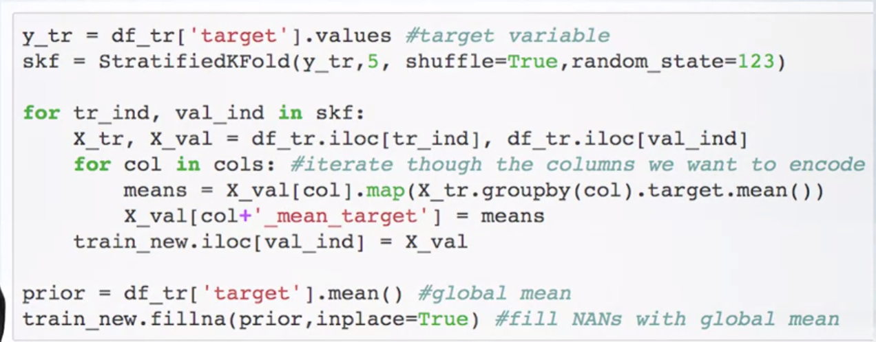

It may seem that we have completely avoided leakage from target variable.

Unfortunately, it's not true.

Skf here gives us the indexed for all the 5 folds we are going to make.

Looping through each fold after that. We get the training and validation data separated.

Then for the set of columns of whom mean encoding has to be found out, we are putting

Validation mean encodings based on training data target mean calculation.

As val_ind in its entire 5 iteration for loop will cover the whole dataset one chunk by chunk. We have created encodings for the whole dataset and saved this in train_new now.

All we have to do is use train_new from now on.

Finally, some rare categories may be present only in a single fold.

So we don't have the data to estimate target mean for them.

That's why we end up with some nans.

We can fill them with global mean.

Now, let's return to the question of whether

we leak information about target variable or not.

Consider the following example.

Here we want to encode Moscow via leave-one-out scheme.

For the first row, we get 0.5, because there are two 1s and

two 0s in the rest of rows.

Similarly, for the second row we get 0.25 and so on.

But look closely, all the resulting and the resulting features.

It perfect splits the data, rows with feature mean equal or

greater than 0.5 have target 0 and the rest of rows has target 1.

We didn't explicitly use target variable, but our encoding is biased.

Furthermore, this effect remains valid even for the K-Fold scheme, just milder.

So is this type of regularization useless?

Definitely not.

In practice, if you have enough data and use four or

five folds, the encodings will work fine with this regularization strategy.

Just be careful and use correct validation.

**Now, let's return to the question of whether**

**we leak information about target variable or not.**

**Consider the following example?**

Here we want to encode Moscow via leave-one-out scheme.

For the first row, we get 0.5, because there are two 1s and

two 0s in the rest of rows.

Similarly, for the second row we get 0.25 and so on.

But look closely, all the resulting and the resulting features.

It perfect splits the data, rows with feature mean equal or

greater than 0.5 have target 0 and the rest of rows has target 1.

We didn't explicitly use target variable, but our encoding is biased.

So it automatically splits the data in terms of the type of target value and created grouping which

Is again hard values to the type of target which we were trying to avoid. Now again as values greator

Has target 0 and values smaller than 0.5 has target 1 this during test will predict in this way and

Thatswhy if there will be a target slightly different in test itll predict wrong.

This doesn’t mean this things is completely useless. This is still quite useful.

Furthermore, this effect remains valid even for the K-Fold scheme, just milder.

**SMOOTHING**

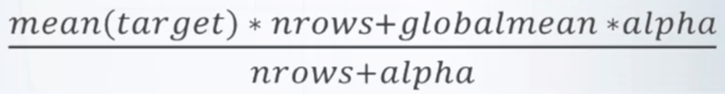

Another regularization method is smoothing.

It's based on the following idea.

If category is big, has a lot of data points, then we can

trust this to encoding, but if category is rare it's the opposite.

Formula on the slide uses this idea.

It has hyper parameter alpha that controls the amount of regularization.

When alpha is zero, we have no regularization, and

when alpha approaches infinity everything turns into globalmean.

4:36

In some sense alpha is equal to the category size we can trust.

It's also possible to use some other formula, basically anything that punishes

encoding smaller categories can be considered smoothing.

Smoothing obviously won't work on its own but

we can combine it with for example, CD loop regularization.

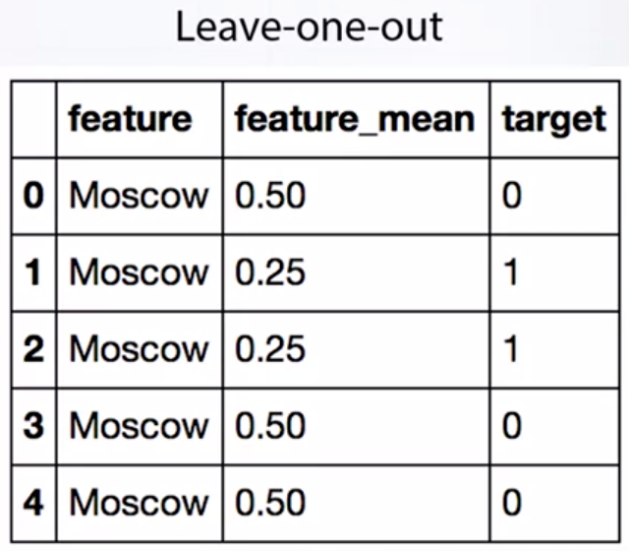

**REGULARIZATION.NOISE**

Another way to regularize encoding is to add some noise without regularization.

Meaning encodings have better quality for

the data than for the test data.

And by adding noise, we simply degrade the quality of encoding on training data.

This method is pretty unstable, it's hard to make it work.

The main problem is the amount of noise we need to add.

Too much noise will turn the feature into garbage,

while too little noise means worse regularization.

This method is usually used together with leave one out regularization.

You need to diligently fine tune it.

So, it's probably not the best option if you don't have a lot of time.

**REGULARIZATION.EXPANDING MEAN**

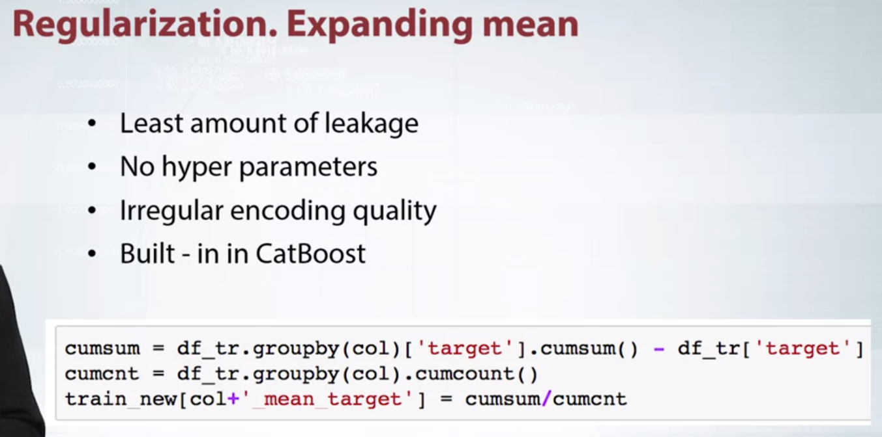

The idea is very simple.

We fix some sorting order of our data and

use only rows from zero to n minus one to calculate encoding for row n.

You can check simple implementation in the code snippet.

Cumsum stores cumulative sum of target variable up to

the given row and cumcnt stores cumulative count.

This method introduces the least amount of leakage from target variable and

it requires no hyper parameter tuning.

The only downside is that feature quality is not uniform.

But it's not a big deal.

We can average models

on encodings calculated from different data permutations.

It's also worth noting that it is expanding mean method

that is used in CatBoost grading, boosting to it's library,

which proves to perform magnificently on data sets with categorical features.

Each of them has its own advantages and disadvantages.

Sometimes unintuitively we introduce target variable leakage.

But in practice, we can bear with it.

Personally, I recommend CV loop or expanding mean methods for

practical tasks.

They are the most robust and easy to tune.

**GENERALIZATION AND EXTENSION**

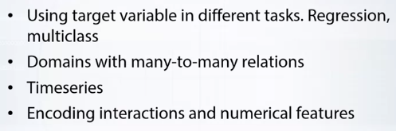

**For regression and multiclass**

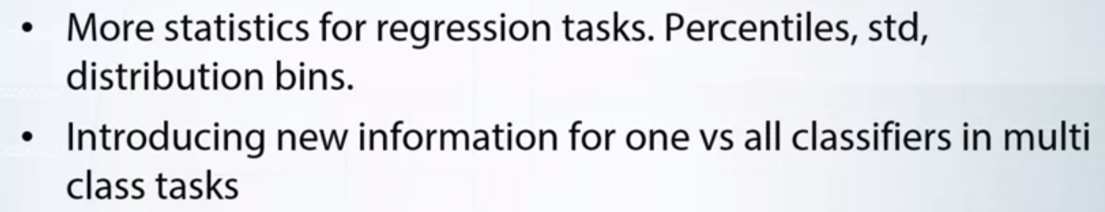

Let's start with regression tasks. They are actually more flexible for feature encoding. Unlike binary classification where a mean is frankly the only meaningful statistic we can extract from target variable. In regression tasks, we can try a variety of statistics, like medium, percentile, standard deviation of target variable. We can even calculate some distribution bins. For example, if target variable is distributed between 1 and 100, we can create 10 bin features. In the first feature, we'll count how many data points have targeted between 1 and 10, in the second between 10 and 20 and so on.

Of course, we need to realize all of these features.

In a nutshell, regression tasks are like classification. Just more flexible in terms of feature engineering.

Men encoding for multi-class tasks is also pretty straightforward. For every feature we want to encode, we will have n different encodings where n is the number of classes. It actually has non obvious advantage. Three models for example, usually solve multi-class task in one versus old fashion. So every class had a different model, and when we feed that model, it doesn't have any information about the structure of other classes because they are merge into one entity.

Therefore, together with mean encodings, we introduce some additional information about the structure of other classes. The domains with many-to-many relations are usually very complex and require special approaches to create mean encodings.

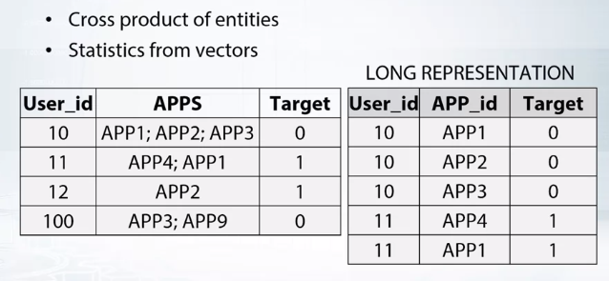

consider an example. Binary classification task for users based on apps installed on their smartphones.

Each user may have multiple apps and each app is used by multiple users. Hence, many-to-many relation.

We want to mean encode apps. The hard part we need to deal with is that the user may have a lot of apps.

So let's take a cross product of user and app entities. It will result in a so called long representation of data. We will have a role for each user app pair.

Using this table, we can naturally calculate mean encoding for apps.

So now every app is encoded with target mean, but how to map it back to users. Every user has a number of apps, so instead of app1, app2, app3, we will now have a vector like 0.1, 0.2, 0.1 value of their mean encodings. That was pretty simple. We can collect various statistics from those vectors, like mean, minimal, maximum, standard deviation, and so on.

**TIME SERIES**

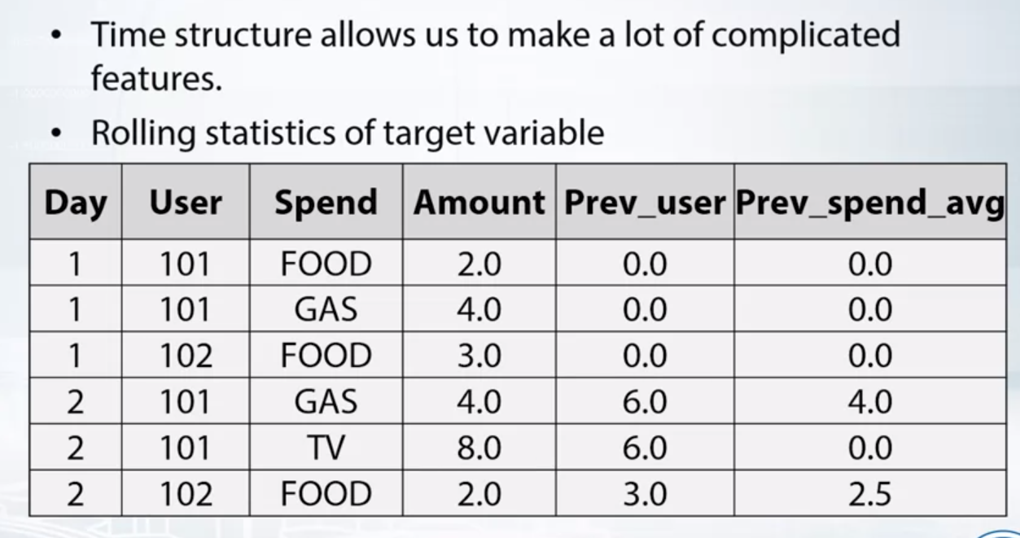

So far we assume that our data has no inner structure, but with time series we can obviously use future information.

On one hand, it's a limitation, on the other hand, it actually allows us to make some complicated features.

In data sets without time component when encoding the category, we are forced to use all the rules to calculate the statistic. It makes no sense to choose some subset of rules. Presence of time changes it. For a given category, we can't. For example, calculate the mean from previous day, previous two days, previous week, etc.

Consider an example.

We need to predict which categories users spends money. In these two examples we have a period of two days, two users, and three spending categories. Some good features would be the total amount of money users spent in previous day. An average amount of money spent by all users in a given category. So, in day 1, user 101 spends $6, user 102, $3. Therefore, we feel those numbers as future values for day 2. Similarly, with the average amount by category.

The more data we have, the more complicated features we can create.

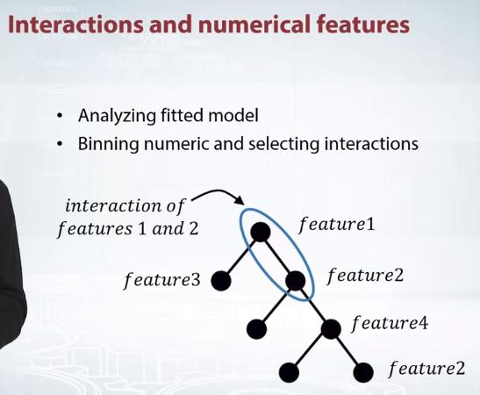

In practice, it is often been official to mean encode numeric features and some combination of features. To encode a numeric feature, we only need to bin it and then treat as categorical.

Now, we need to answer two questions. First, how to bin numeric feature, and second how to select useful combination of features. Well, we can find it out from a model structure by analyzing the trees. So at first, we take for example, XGBOOST model and raw features without any encodings. Let's start with numeric features.

If numeric feature has a lot of SPLIT points, it means that it has some complicated dependency with target and its was trying to mean encode it. Furthermore, these exact split points may be used to bin the feature.

So by analyzing model structure, we both identify suspicious numeric feature and found a good way to bin it.

It's going to be a little harder with selecting interactions, but nothing extraordinary.

First, let's define how to extract to way interaction from decision tree.

The process will be similar for three way, four way arbitrary way interactions.

So two features interact in a tree if they are in two neighbouring notes. With that in mind, we can iterate through all the trees in the model and calculate how many times each feature interaction appeared.

The most frequent interactions are probably worthy of mean encoding. For example, if we found that feature one and feature two pair is most frequent, then we can concatenate that those feature values in our data. And mean encode resulting interaction.



Now let me illustrate how important interaction encoding may be.

Amazon Employee Access Challenge Competition has a very specific data set. There are only nine categorical features. If we blindly fit say like GBM model on the raw features, then no matter how we return the parameters, we'll score in a 0.87 AUC range. Which will place roughly on 700 position on the leaderboard.

Furthermore, even if we mean encode all the labels, we won't have any progress.

But if we fit cat boost model, which internally mean encodes some feature interactions, we will immediately score in 0.91 range, which will place us onto win this position. The difference in both absolute AUC values and relative leaderboard positions is tremendous.

Also note that cat boost is no silver bullet. In order to get even higher on the leaderboard, would still need to manually add more mean encoded interactions.

In general, if you participate in a competition with a lot of categorical variables, it's always worth trying to work with interactions and mean encodings.

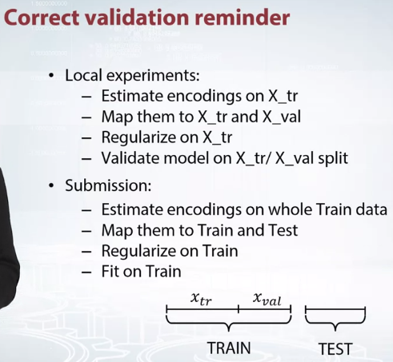

remind you about correct validation process.

During all local experiments, you should at first split data in X_tr and X_val parts.

Estimate encodings on X_tr, map them to X_tr and X_val, and then regularize them on X_tr randomly after that validate your model on X_tr and X_val split. Don't even think about estimating encodings before splitting the data.

And at submission stage, you can estimate encodings on whole train data. Map it to train and test,then apply regularization on training data and finally fit a model. And note that you should have already decided on regularization method and its strength in local experiments.

**Advantage and disadvantages of mean encodings**

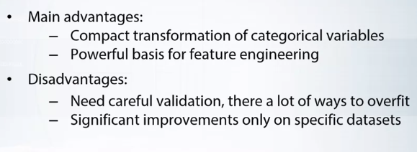

# Question 1

## What can be an indicator of usefulness of mean encodings?

Correct answers:

* Categorical variables with lots of levels.

Incorrect answers:

* A lot of binary variables. This is not an indicator because the majority of ML models deal with binary variables just fine. But keep in mind that there could be special cases when encoding binary variables with target mean may be useful. For example, KNN models might work better on mean-encoded binary features.
* Learning to rank task. There is no connection between mean encodings and learning to rank tasks.

# Question 2

## What is the purpose of regularization in case of mean encodings?

Correct answers:

* Regularization reduces target variable leakage during the construction of mean encodings.
* Regularization allows us to better utilize mean encodings. Only with regularization we can use mean encodings to the fullest.

Incorrect answers:

* Regularization allows to make feature space more sparse. Don't mix it up with L1 penalty.

# Question 3

## What is the correct way of validation when doing mean encodings?

Correct answers:

* First split the data into train and validation, then estimate encodings on train, then apply them to validation, then validate the model on that split. That way we avoid target variable leakage.

Incorrect answers:

* Fix cross-validation split, use that split to calculate mean encodings with CV-loop regularization, use the same split to validate the model. This way we will overfit, because target from validation is used to calculate mean encodings on train. So the model implicitly uses this information which results in mild target leakage.
* Calculate mean encodings on all train data, regularize them, then validate your model on random validation split. This way we will overfit even more, because target from validation is explicitly used to calculate mean encodings.

# Question 4

## Suppose we have a data frame 'df' with categorical variable 'item_id' and target variable 'target'.We create 2 different mean encodings:

## 1)via df['item_id_encoded1'] = df.groupby('item_id')['target'].transform('mean')

## 2)via OneHotEncoding item_id, fitting Linear Regression on one hot-encoded version of item_id and then calculating 'item_id_encoded2' as a prediction from this linear regression on the same data.

Correct answers:

* 'item_id_encoded1' and 'item_id_encoded2' will be essentially the same only if linear regression was fitted without a regularization. Remember, after one hot encoding there will be only one '1' in each row and the rest - zeros. Since we don't have a regularization, coefficients of each variable would be target means of item_id corresponding to that variable.

Incorrect answers:

* 'item_id_encoded1' and 'item_id_encoded2' will be essentially the same. Thats not always true. With regularization it will not converge to the same values as 'item_id_encoded1'
* 'item_id_encoded1' and 'item_id_encoded2' may hugely vary due to rare categories. No, it has nothing to do with categorical sizes.

**NOTEBOOK ASSIGNMENT CODING TECHNIQUES**

The whole notebook is imp. Below are some snippets

taken out due to high importance.

from itertools import product

to do cartersian product between A and B.

print list(product([1,2,3],[3,4]))

[(1, 3), (1, 4), (2, 3), (2, 4), (3, 3), (3, 4)]

A = [[1,2,3],[3,4,5]]

print list(product(*A))

[(1, 3), (1, 4), (1, 5), (2, 3), (2, 4), (2, 5), (3, 3), (3, 4), (3, 5)]

print list(product([1,2,3],repeat = 2))

[(1, 1), (1, 2), (1, 3), (2, 1), (2, 2), (2, 3), (3, 1), (3, 2), (3, 3)]

Np.vstack()

Stack arrays in sequence vertically (row wise)

cartesianProduct = [(x,y) for x in A for y in B]

# For every month we create a grid from all shops/items combinations from that month

grid = []

for block_num in sales['date_block_num'].unique():

cur_shops = sales[sales['date_block_num']==block_num]['shop_id'].unique()

cur_items = sales[sales['date_block_num']==block_num]['item_id'].unique()

grid.append(np.array(list(product(*[cur_shops, cur_items, [block_num]])),dtype='int32'))

# turn the grid into pandas dataframe

grid = pd.DataFrame(np.vstack(grid), columns = index_cols,dtype=np.int32)

here vstack() joins arrays of array into one array having lists getting created as a row and then being created as DataFrame.

# First grouping based on "Team"

# Within each team we are grouping based on "Position"

gkk = daf.groupby(['Team', 'Position'])

# Print the first value in each group

gkk.first()

below A and B were the column names and sum min max are the string values you can pass to the function to do the tasks.

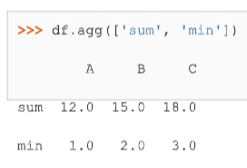

Different aggregations per column.

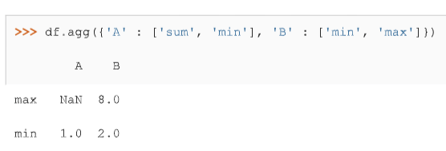

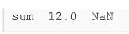

# Calculate a mapping: {item_id: target_mean}

item_id_target_mean = all_data.groupby('item_id').target.mean()

# In our non-regularized case we just *map* the computed means to the `item_id`'s

all_data['item_target_enc'] = all_data['item_id'].map(item_id_target_mean)

'''

Differently to `.target.mean()` function `transform`

will return a dataframe with an index like in `all_data`.

Basically this single line of code is equivalent to the two lines above creating mapping and then putting it to axis.

'''

all_data['item_target_enc'] = all_data.groupby('item_id')['target'].transform('mean')

cumcount is only available with pandas groupby

cumsum is only available elsewhere too.

# **Mean encodings**

In this programming assignment you will be working with 1C dataset from the final competition. You are asked to encode item_id in 4 different ways:

1) Via KFold scheme;

2) Via Leave-one-out scheme;

3) Via smoothing scheme;

4) Via expanding mean scheme.

**You will need to submit** the correlation coefficient between resulting encoding and target variable up to 4 decimal places.

### **General tips**

* Fill NANs in the encoding with 0.3343.
* Some encoding schemes depend on sorting order, so in order to avoid confusion, please use the following code snippet to construct the data frame. This snippet also implements mean encoding without regularization.

**import** pandas **as** pd

**import** numpy **as** np

**from** itertools **import** product

**from** grader **import** Grader

# **Read data**

sales = pd.read_csv('../readonly/final_project_data/sales_train.csv.gz')

sales.shape

sales.head()

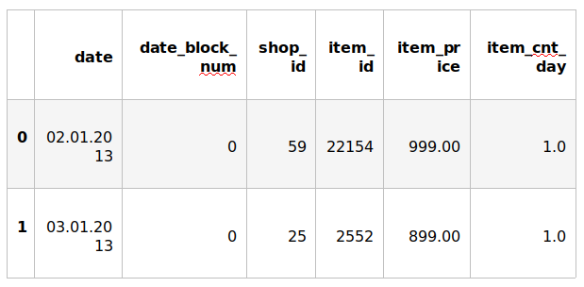

**Aggregate data**

Since the competition task is to make a monthly prediction, we need to aggregate the data to montly level before doing any encodings. The following code-cell serves just that purpose.

index_cols = ['shop_id', 'item_id', 'date_block_num']

​

*# For every month we create a grid from all shops/items combinations from that month*

grid = []

**for** block_num **in** sales['date_block_num'].unique():

cur_shops = sales[sales['date_block_num']==block_num]['shop_id'].unique()

cur_items = sales[sales['date_block_num']==block_num]['item_id'].unique()

grid.append(np.array(list(product(**\***[cur_shops, cur_items, [block_num]])),dtype='int32'))

​

*#turn the grid into pandas dataframe*

grid = pd.DataFrame(np.vstack(grid), columns = index_cols,dtype=np.int32)

​

​

*#get aggregated values for (shop_id, item_id, month)*

gb = sales.groupby(index_cols,as_index=**False**).agg({'item_cnt_day':{'target':'sum'}})

​

*#fix column names*

gb.columns = [col[0] **if** col[**-**1]=='' **else** col[**-**1] **for** col **in** gb.columns.values]

*#join aggregated data to the grid*

all_data = pd.merge(grid,gb,how='left',on=index_cols).fillna(0)

*#sort the data*

all_data.sort_values(['date_block_num','shop_id','item_id'],inplace=**True**)

/opt/conda/lib/python3.6/site-packages/pandas/core/groupby.py:4036: FutureWarning: using a dict with renaming is deprecated and will be removed in a future version

return super(DataFrameGroupBy, self).aggregate(arg, *args, **kwargs)

all_data.head()

# 

# **Mean encodings without regularization**

After we did the techinical work, we are ready to actually *mean encode* the desired item_id variable.

Here are two ways to implement mean encoding features *without* any regularization. You can use this code as a starting point to implement regularized techniques.

#### **Method 1**

*# Calculate a mapping: {item_id: target_mean}*

item_id_target_mean = all_data.groupby('item_id').target.mean()

​

*# In our non-regularized case we just *map* the computed means to the `item_id`'s*

all_data['item_target_enc'] = all_data['item_id'].map(item_id_target_mean)

​

*# Fill NaNs*

all_data['item_target_enc'].fillna(0.3343, inplace=**True**)

​

*# Print correlation*

encoded_feature = all_data['item_target_enc'].values

print(np.corrcoef(all_data['target'].values, encoded_feature)[0][1])

0.483038698862

#### **Method 2**

'''

Differently to `.target.mean()` function `transform`

will return a dataframe with an index like in `all_data`.

Basically this single line of code is equivalent to the first two lines from of Method 1.

'''

all_data['item_target_enc'] = all_data.groupby('item_id')['target'].transform('mean')

​

*# Fill NaNs*

all_data['item_target_enc'].fillna(0.3343, inplace=**True**)

​

*# Print correlation*

encoded_feature = all_data['item_target_enc'].values

print(np.corrcoef(all_data['target'].values, encoded_feature)[0][1])

0.483038698862

See the printed value? It is the correlation coefficient between the target variable and your new encoded feature. You need to **compute correlation coefficient** between the encodings, that you will implement and **submit those to coursera**.

grader = Grader()

# **1. KFold scheme**

Explained starting at 41 sec of [Regularization video](https://www.coursera.org/learn/competitive-data-science/lecture/LGYQ2/regularization).

**Now it's your turn to write the code!**

You may use 'Regularization' video as a reference for all further tasks.

First, implement KFold scheme with five folds. Use KFold(5) from sklearn.model_selection.

1. Split your data in 5 folds with sklearn.model_selection.KFold with shuffle=False argument.
2. Iterate through folds: use all but the current fold to calculate mean target for each level item_id, and fill the current fold.  
   * See the **Method 1** from the example implementation. In particular learn what map and pd.Series.map functions do. They are pretty handy in many situations.

*# YOUR CODE GOES HERE*

**from** sklearn.model_selection **import** KFold

kf = KFold(n_splits=5, shuffle=**False**)

​

encoded_feature = np.array(np.zeros)

**for** train_index, val_index **in** kf.split(all_data.target):

train_data, val_data = all_data.iloc[train_index], all_data.iloc[val_index]

all_data['item_target_enc'].iloc[val_index] = val_data.item_id.map(train_data.groupby('item_id').target.mean())

​

*# Fill NaNs*

all_data['item_target_enc'].fillna(0.3343, inplace=**True**)

encoded_feature = all_data['item_target_enc'].values

​

*# You will need to compute correlation like that*

corr = np.corrcoef(all_data['target'].values, encoded_feature)[0][1]

print(corr)

grader.submit_tag('KFold_scheme', corr)

/opt/conda/lib/python3.6/site-packages/pandas/core/indexing.py:179: SettingWithCopyWarning:

A value is trying to be set on a copy of a slice from a DataFrame

See the caveats in the documentation:<http://pandas.pydata.org/pandas-docs/stable/indexing.html#indexing-view-versus-copy>

self._setitem_with_indexer(indexer, value)

0.41645907128

Current answer for task KFold_scheme is: 0.41645907128

# **2. Leave-one-out scheme**

Now, implement leave-one-out scheme. Note that if you just simply set the number of folds to the number of samples and run the code from the **KFold scheme**, you will probably wait for a very long time.

To implement a faster version, note, that to calculate mean target value using all the objects but one *given object*, you can:

1. Calculate sum of the target values using all the objects.
2. Then subtract the target of the *given object* and divide the resulting value by n_objects - 1.

Note that you do not need to perform 1. for every object. And 2. can be implemented without any for loop.

It is the most convenient to use .transform function as in **Method 2**.

*# YOUR CODE GOES HERE*

all_data['item_target_enc'] = all_data.groupby('item_id').target.transform('sum') **-** all_data['target']

all_data['item_target_enc'] /= all_data['item_id'].map(all_data.groupby('item_id').target.count()**-**1)

​

encoded_feature = all_data.item_target_enc.values

corr = np.corrcoef(all_data['target'].values, encoded_feature)[0][1]

print(corr)

grader.submit_tag('Leave-one-out_scheme', corr)

0.480384831129

Current answer for task Leave-one-out_scheme is: 0.480384831129

# **3. Smoothing**

Explained starting at 4:03 of [Regularization video](https://www.coursera.org/learn/competitive-data-science/lecture/LGYQ2/regularization).

Next, implement smoothing scheme with α=100α=100. Use the formula from the first slide in the video and 0.33430.3343 as globalmean. Note that nrows is the number of objects that belong to a certain category (not the number of rows in the dataset).

*# YOUR CODE GOES HERE*

all_data.item_target_enc = all_data.groupby('item_id').target.transform('mean')

nrows = all_data['item_id'].map(all_data.groupby('item_id').target.count())

all_data.item_target_enc *= nrows

all_data.item_target_enc += (0.3343 **\*** 100)

all_data.item_target_enc /= (nrows **+** 100)

​

encoded_feature = all_data.item_target_enc.values

​

corr = np.corrcoef(all_data['target'].values, encoded_feature)[0][1]

print(corr)

grader.submit_tag('Smoothing_scheme', corr)

0.48181987971

Current answer for task Smoothing_scheme is: 0.48181987971

# **4. Expanding mean scheme**

Explained starting at 5:50 of [Regularization video](https://www.coursera.org/learn/competitive-data-science/lecture/LGYQ2/regularization).

0

Finally, implement the *expanding mean* scheme. It is basically already implemented for you in the video, but you can challenge yourself and try to implement it yourself. You will need [cumsum](https://pandas.pydata.org/pandas-docs/stable/generated/pandas.core.groupby.DataFrameGroupBy.cumsum.html) and [cumcount](https://pandas.pydata.org/pandas-docs/stable/generated/pandas.core.groupby.GroupBy.cumcount.html) functions from pandas.

cumsum = all_data.groupby('item_id').target.cumsum() **-** all_data.target

count = all_data.groupby('item_id').cumcount()

all_data.item_target_enc = cumsum**/**count

​

all_data['item_target_enc'].fillna(0.3343, inplace=**True**)

​

encoded_feature = all_data.item_target_enc.values

​

corr = np.corrcoef(all_data['target'].values, encoded_feature)[0][1]

print(corr)

grader.submit_tag('Expanding_mean_scheme', corr)

0.502524521108

Current answer for task Expanding_mean_scheme is: 0.502524521108